NAME: CHRISTINA JOSE MANAKKAL

ROLL NO: 48 CLASS: TE IT B3 PID: 191064

St. Francis Institute of Technology, Mumbai-400 103

**Department Of Information Technology**

A.Y. 2021-2022

Class: TE-IT B, Semester: V

Subject: **DevOps Lab**

**Experiment – 4: To understand Continuous Integration, install and configure Jenkins with Maven/Ant/Gradle to setup a build Job.**

1. **Aim:** To understand Continuous Integration, install and configure Jenkins with Maven
2. **Objectives:** Aim of this experiment is that, the students will be able

* To Integrate and deploy tools like Jenkins and Maven, which is used to build

applications in DevOps environment

1. **Outcomes:** After study of this experiment, the students will be able

* To understand the importance of Jenkins to Build and deploy Software

Applications on server environment.

* Learn about Jenkins (With Architecture)
* To have introduction to Maven / Gradle / Ant

1. **Prerequisite:** Knowledge of software engineering concept of integration
2. **Requirements:** Jenkins,JDK, python, ANT,Personal Computer, Windows operating system, browser, Internet Connection, Microsoft Word.
3. **Pre-Experiment Exercise:**

**Brief Theory:** Refer shared material

1. **Laboratory Exercise**
   * + 1. **Procedure:**

**a. Answer the following:**

* Explain continuous integration

Continuous Integration is a software development process where a code is continuously tested after a commit, to ensure there are no bugs.

In large teams, many developers work on the same code base. Thus, any of the multiple commits can have a bug. With continuous integration, bugs can be identified early and fixed before pushing changes to production. Any new code is integrated into one executable form, termed as a build. If the build is green (i.e. all ok), then the executable artifact can be deployed. If not, the bug needs to be fixed, and the new build is tested again.

* What is Jenkins?

Jenkins is an open-source implementation of a Continuous Integration server written in Java.

* It works with multiple programming languages and can run on various platforms (Windows, Linux, and macOS). It is widely used as a CI (Continuous Integration) & CD (Continuous Delivery) tool.
* It has vast community support, and there are many plugins available for integrating it with other tools like [Slack](https://www.browserstack.com/slack-integration), [GitHub](https://www.browserstack.com/github-integration), Docker. Also, anyone can develop a Jenkins plugin and contribute to it.
* By using Jenkins, software companies can accelerate their software development process, as Jenkins can automate a build and run tests to ensure the functionality is working fine.
* Jenkins supports the entire software development life cycle that includes building, testing, documenting the software and deploying.
* Why use Jenkins?

Jenkins is used to build and test your product continuously, so developers can continuously integrate changes into the build. Jenkins is the most popular open source CI/CD tool on the market today and is used in support of DevOps, alongside other cloud native tools.

Jenkins facilitates continuous integration and continuous delivery in software projects by automating parts related to build, test, and deployment. This makes it easy for developers to continuously work on the betterment of the product by integrating changes to the project.

* Why Jenkins is popular? Mention advantages.
* Originally developed by Kohsuke for continuous integration (CI), today Jenkins orchestrates the entire software delivery pipeline – called continuous delivery. For some organizations automation extends even further, to continuous deployment. Continuous delivery (CD), coupled with a[DevOps culture](https://www.cloudbees.com/devops), dramatically accelerates the delivery of software.
* Jenkins is the most widely adopted solution for continuous delivery, thanks to its extensibility and a vibrant, active community. The Jenkins community offers more than [1,700 plugins](https://plugins.jenkins.io/) that enable Jenkins to integrate with virtually any tool, including all of the best-of-breed solutions used throughout the continuous delivery process. Jenkins continues to grow as the dominant solution for software process automation, continuous integration and continuous delivery and, as of February 2018, there are [more than 165,000 active installations](http://stats.jenkins.io/jenkins-stats/svg/svgs.html) and an estimated 1.65 million users around the world.

ADVANTAGES:

* Jenkins is open-source and free to use. It is a preferred CI/CD tool by early-stage startups as well as large corporations since it has been under development since a long time.
* It is a rich plugin ecosystem. At the time of this article, there were close to 1500+ plugins available for use.
* Jenkins can be integrated with popular cloud platforms such as Amazon EC2, Google Cloud, VMWare vSphere, Digital Ocean, and more.
* Jenkins Pipelines can be extremely useful for realizing CD requirements for large-scale projects.

**b**. **Execute following (Refer the shared material) and attach screenshots:**

* Install Jenkins
* Configure Jenkins with Maven and ANT
* Build jobs in Jenkins

1. **Post-Experiments Exercise**
2. **Extended Theory:**

Nil

1. **Questions:**

* What are the system requirements to install Jenkins?
* Give some important plugins in Jenkins.
* What is Maven and ANT?

1. **Conclusion:**

* Write what was performed in the experiment.
* Write the significance of the topic studied in the experiment.

1. **References:**

<https://jenkins.io/doc/>

<https://www.cloudbees.com/jenkins/what-is-jenkins>

<https://vmokshagroup.com/blog/what-is-jenkins/>

[https://www.infoworld.com/article/3239666/what-is-jenkins-the-ci-server-explained.html](https://www.infoworld.com/article/3239666/what-is-jenkins-the-ci-server-explained.html )

<https://hackr.io/blog/jenkins-interview-questions>

<https://www.edureka.co/blog/interview-questions/jenkins-interview-questions/>

**OUTPUT:**

**jdk installation:**

* Creatingenvironment variables

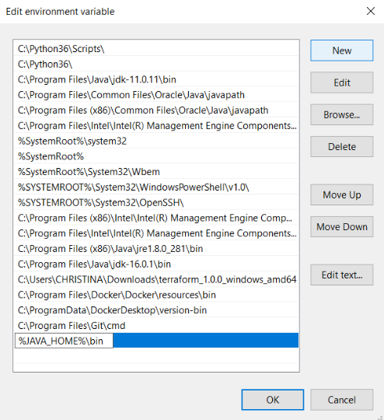

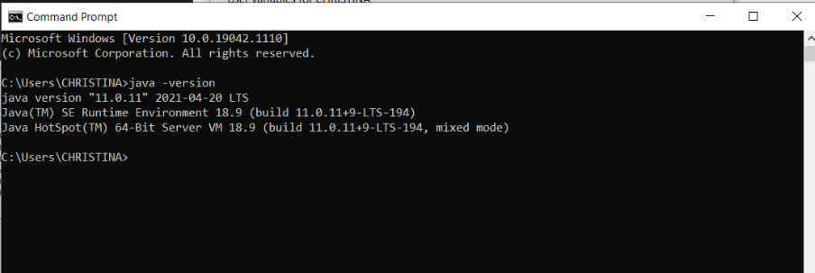

**Jenkins installation:**

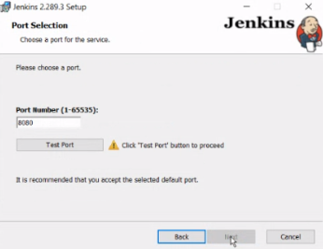

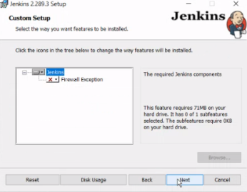

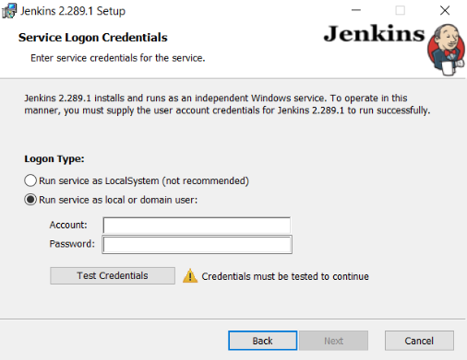

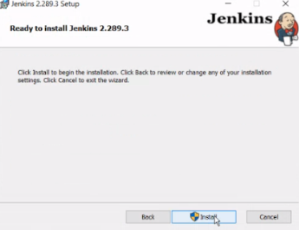

* Go to the path in and get the Administrative Password.

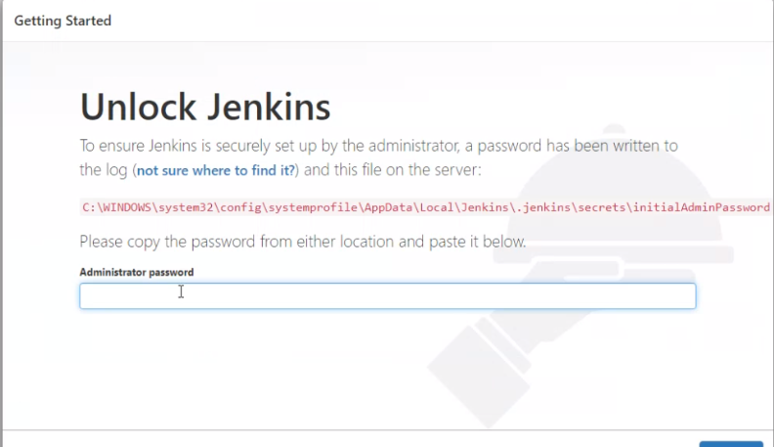

* Open the file initialAdminPassword using notepad and copy the password and paste in the window show above.

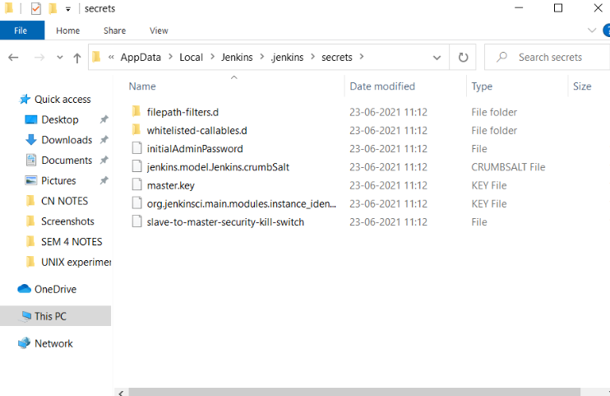

* Install plugins

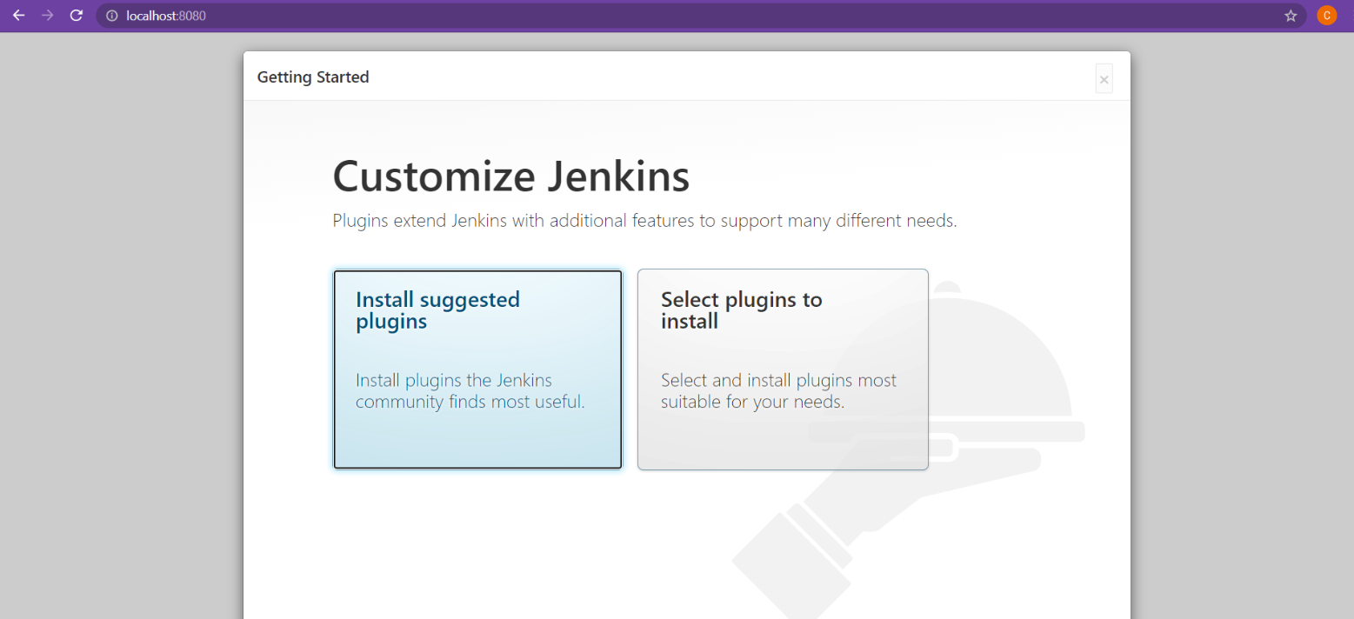

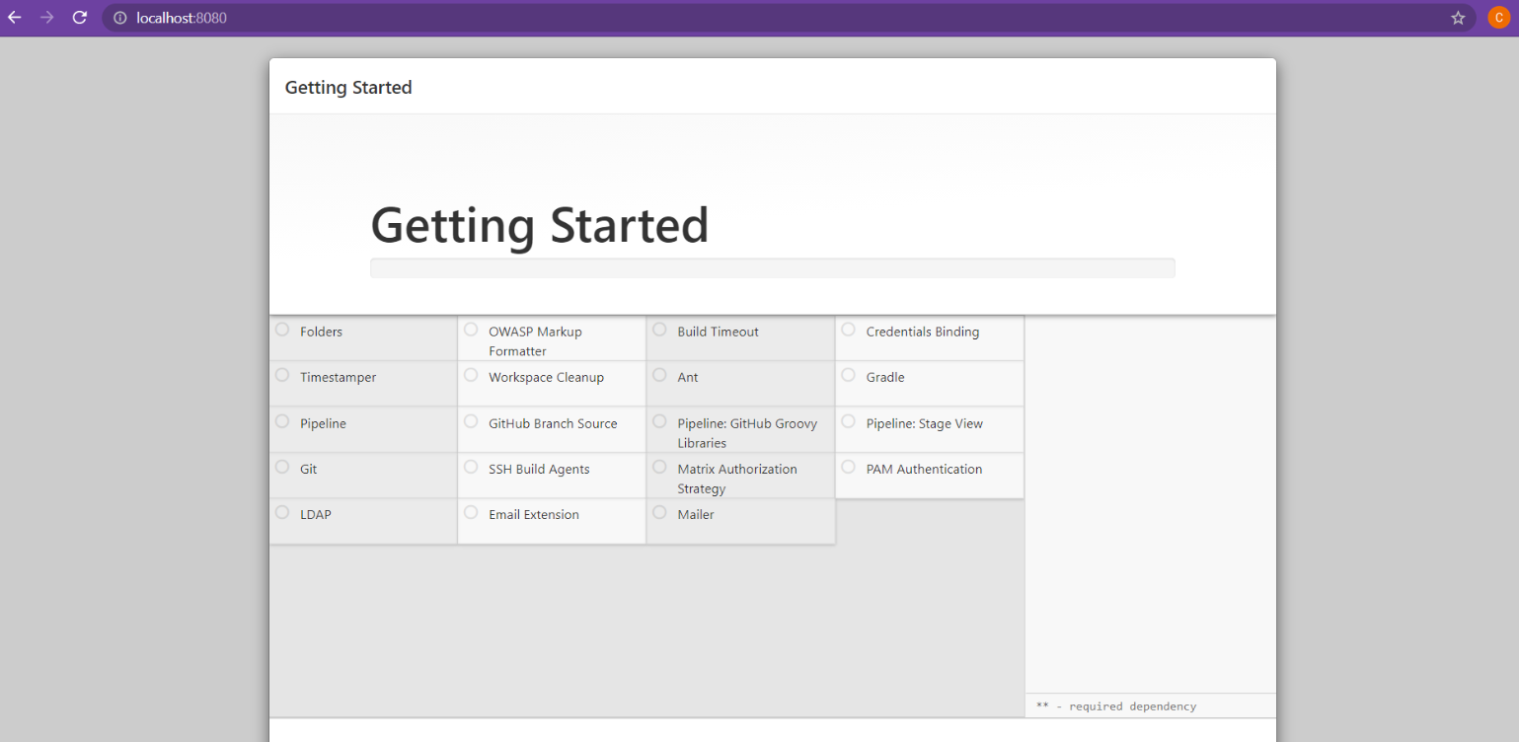

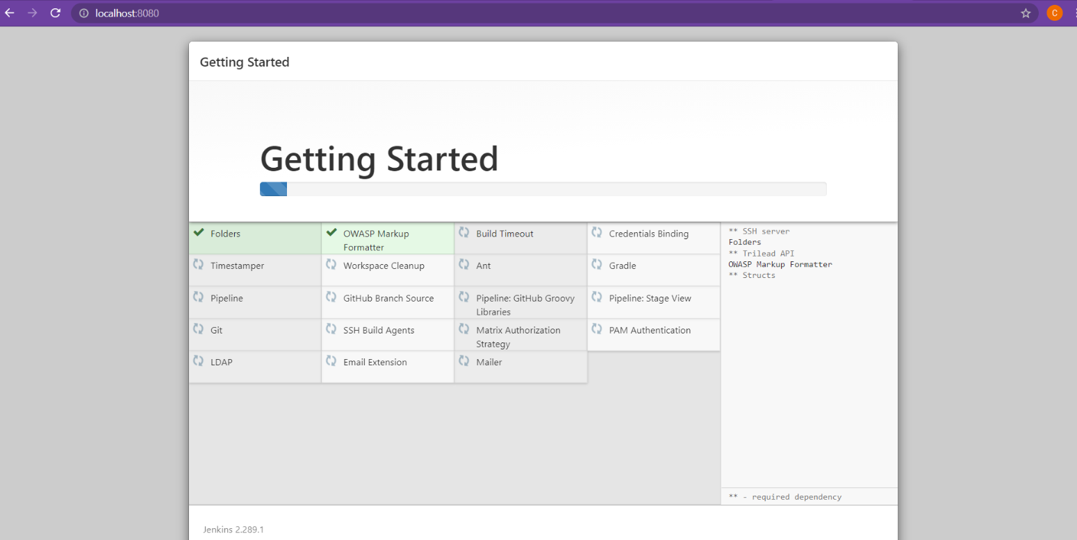

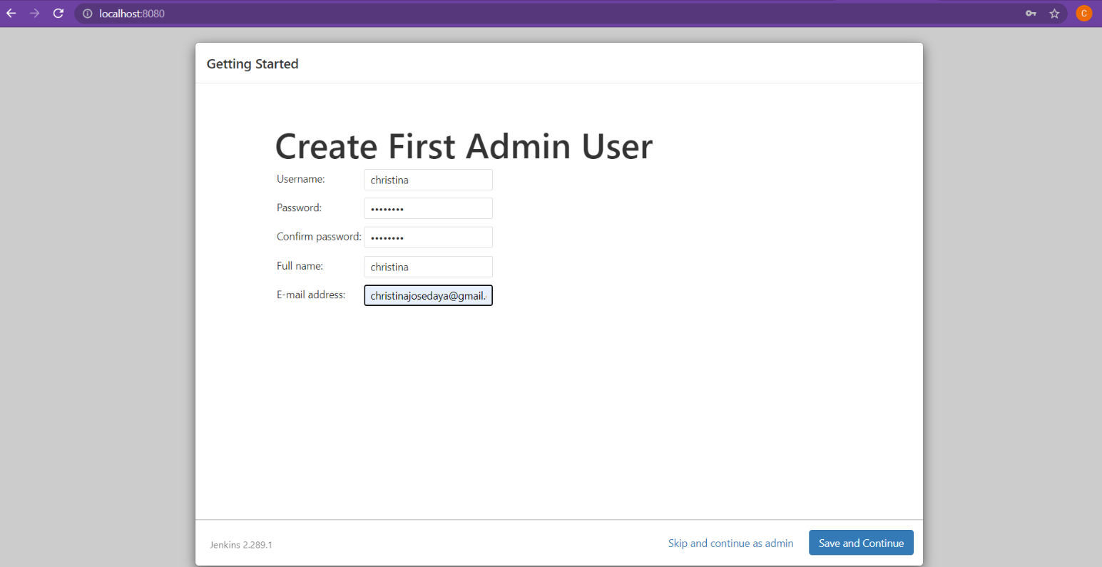

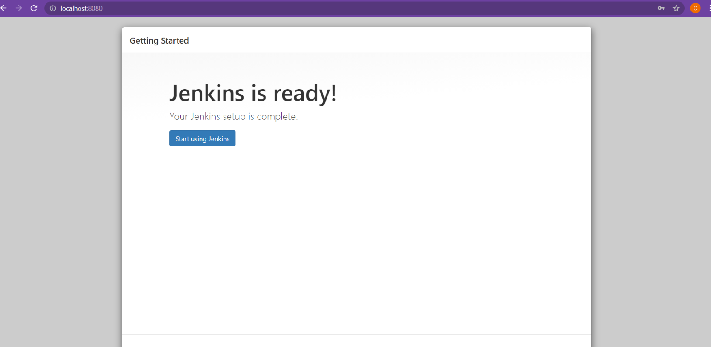

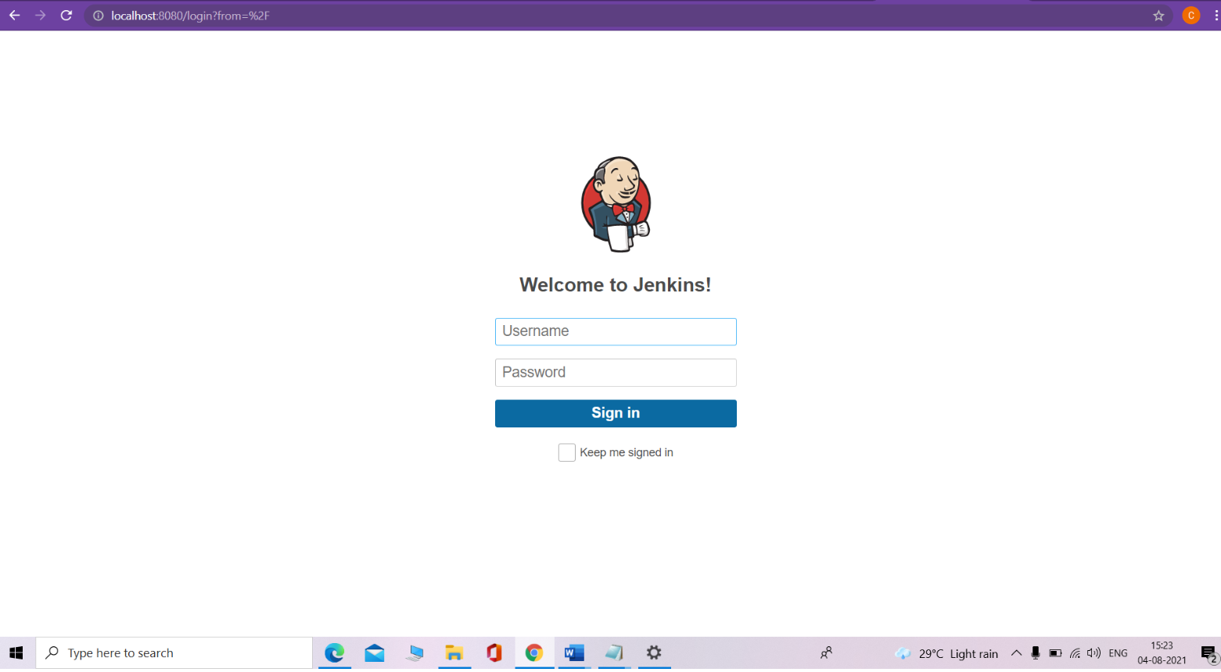

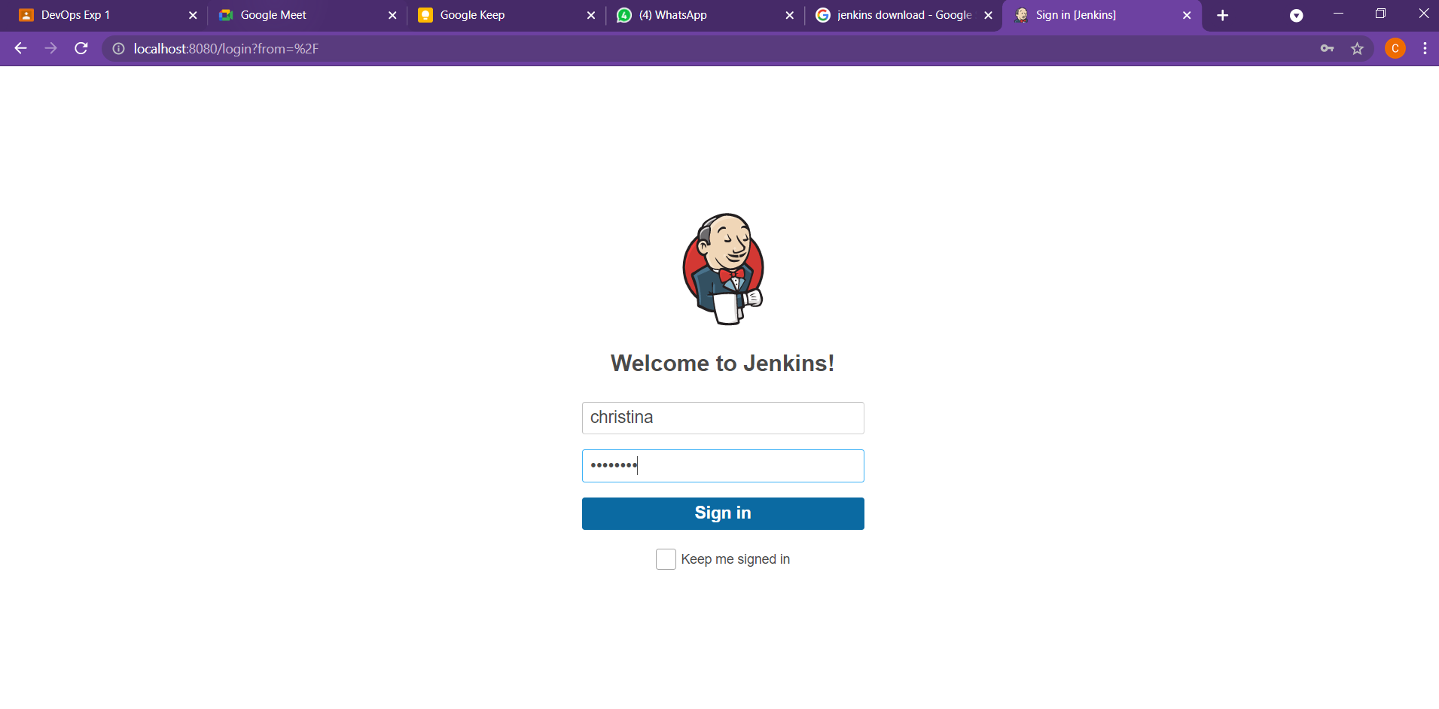

* **Configure Jenkins with Maven/Ant/Gradle – Global tool configuration, manage plugins**

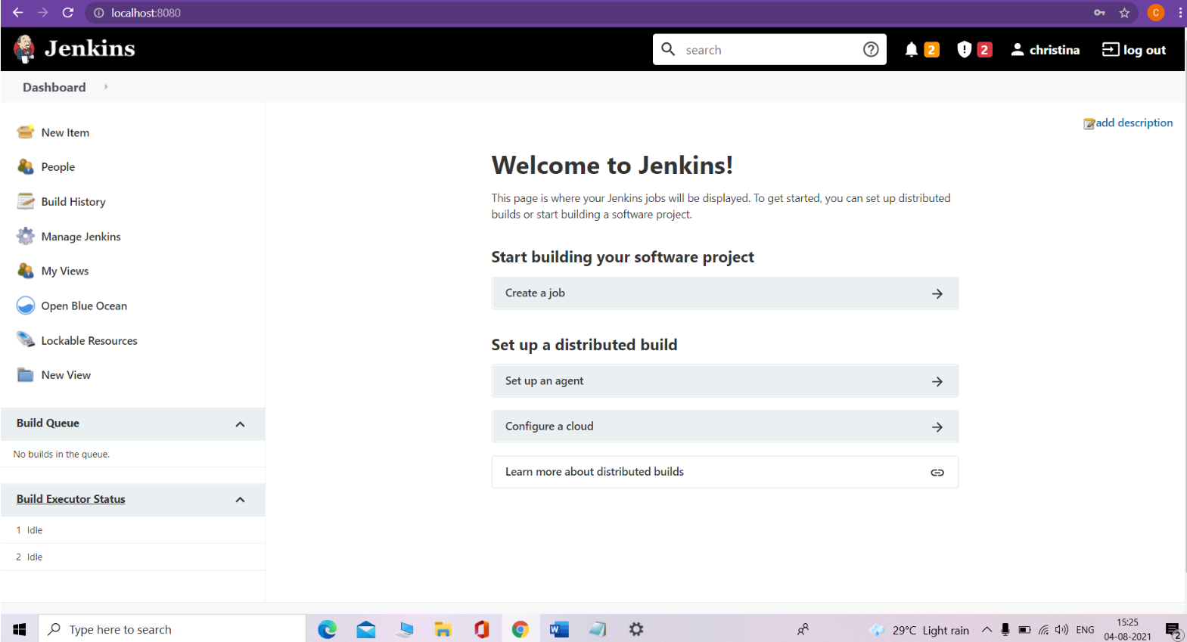

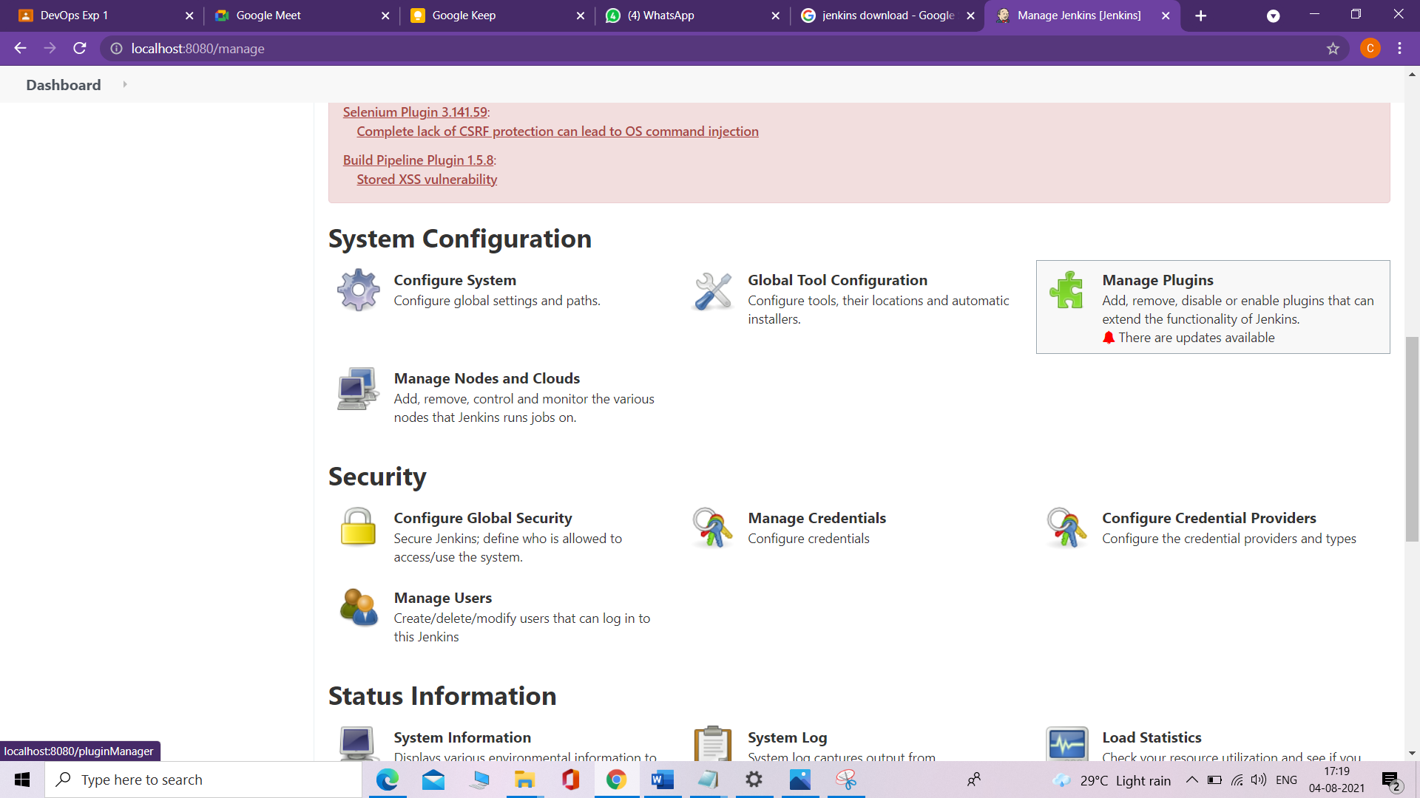

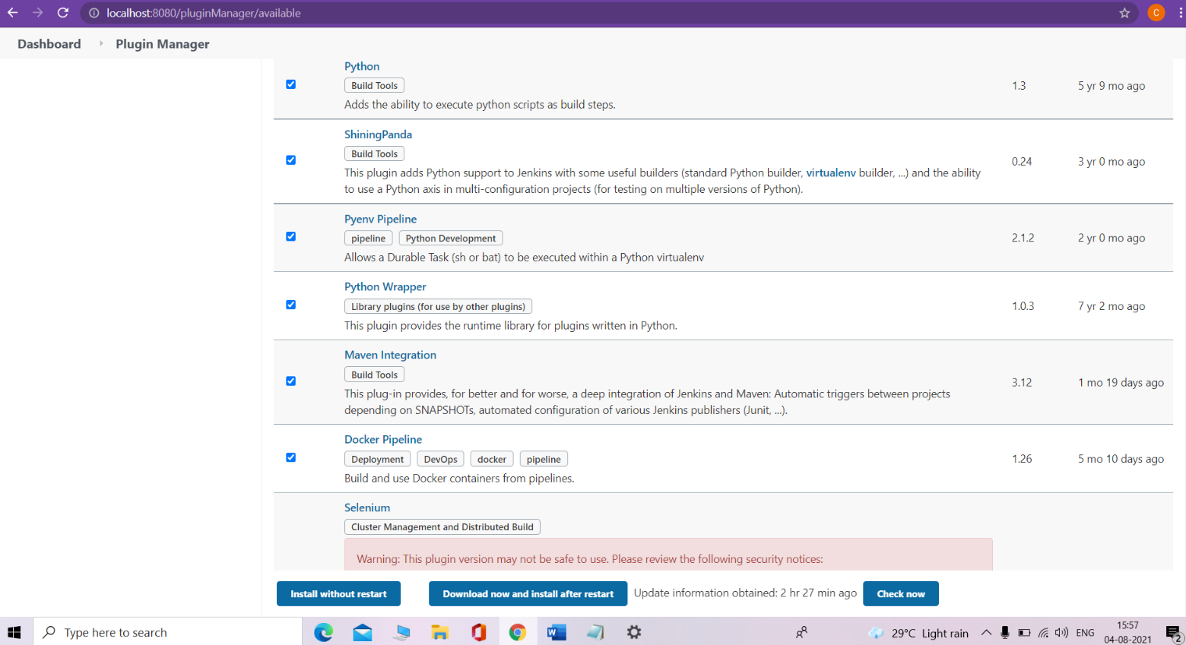

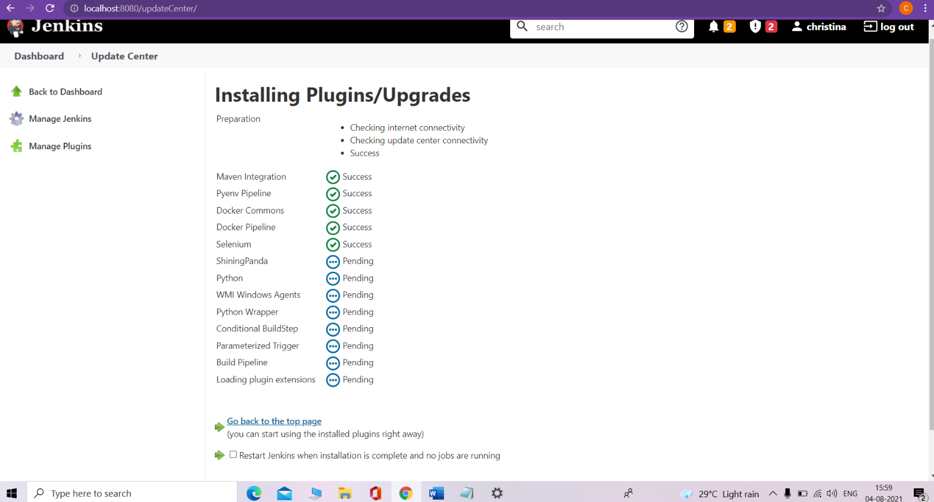

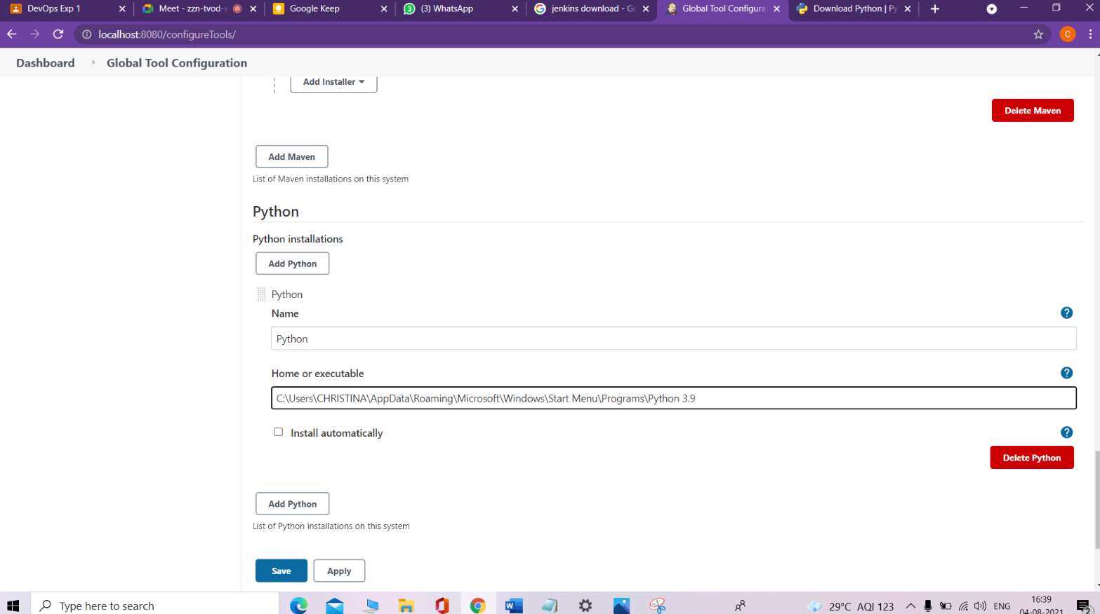

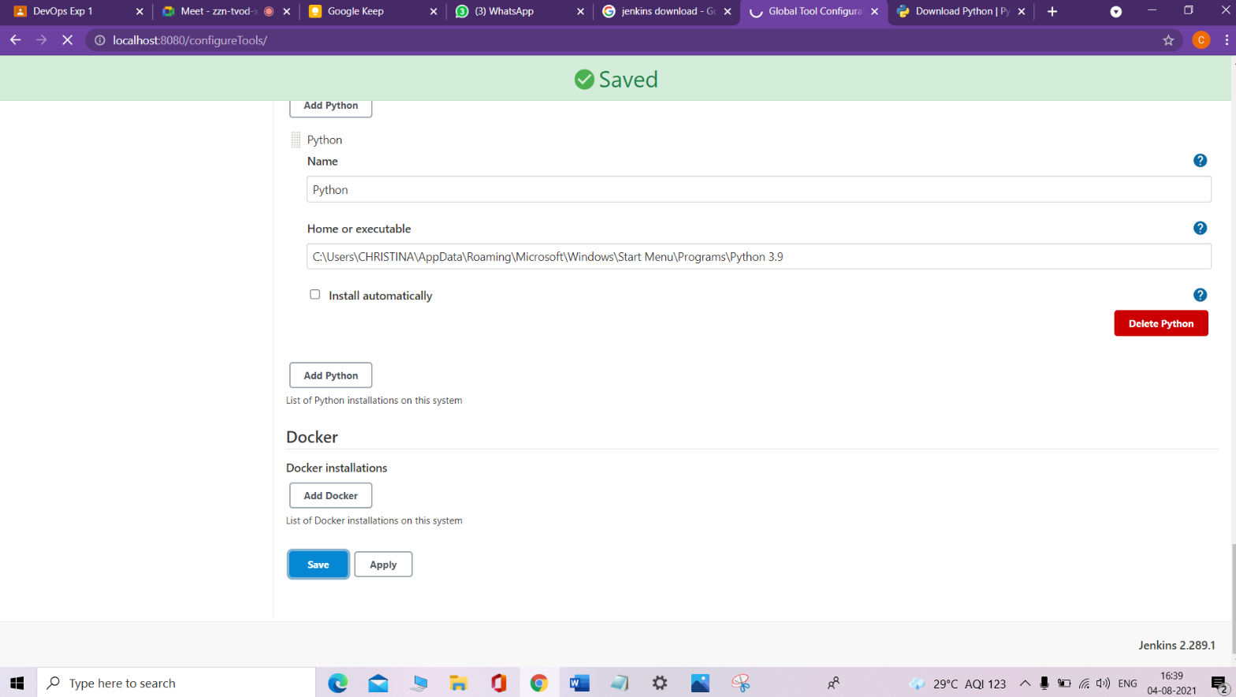

* **Build jobs in Jenkins**

**1. Java freestyle project -Hello world**

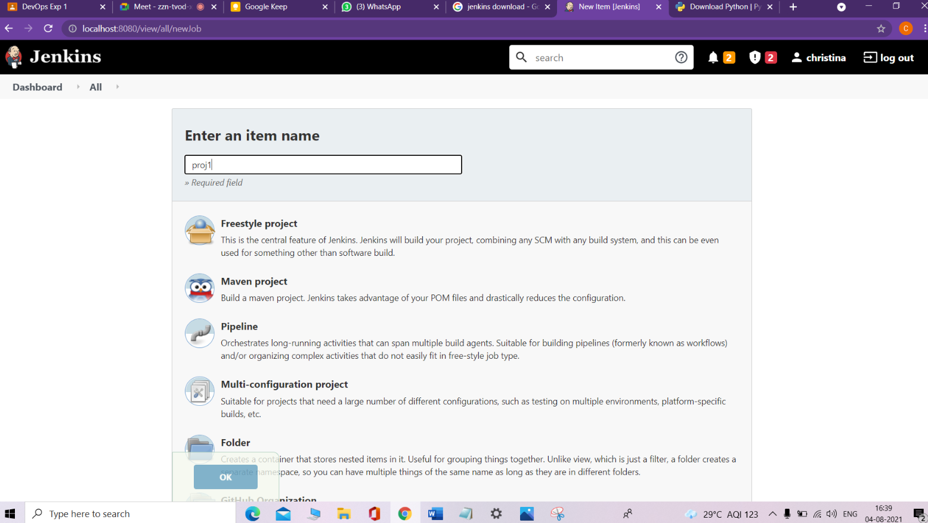

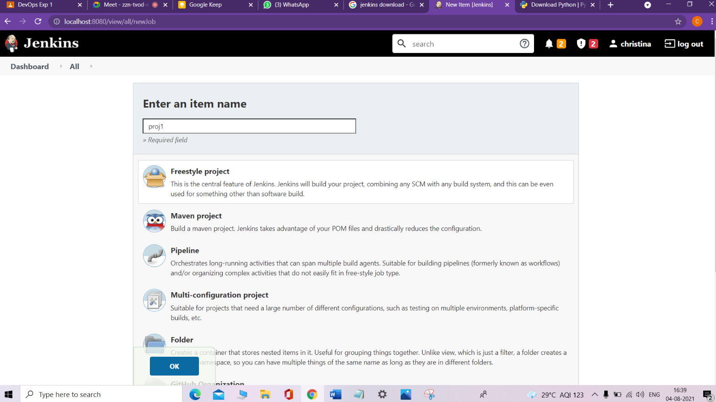

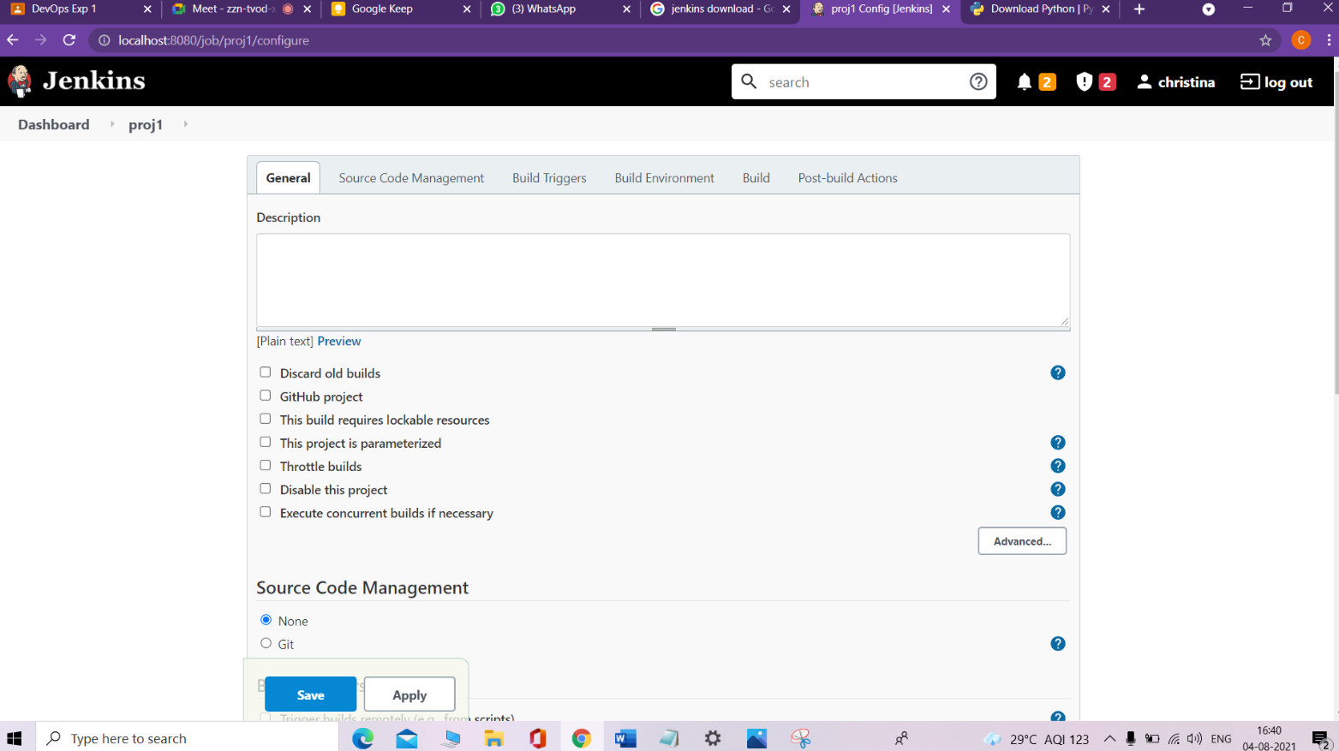

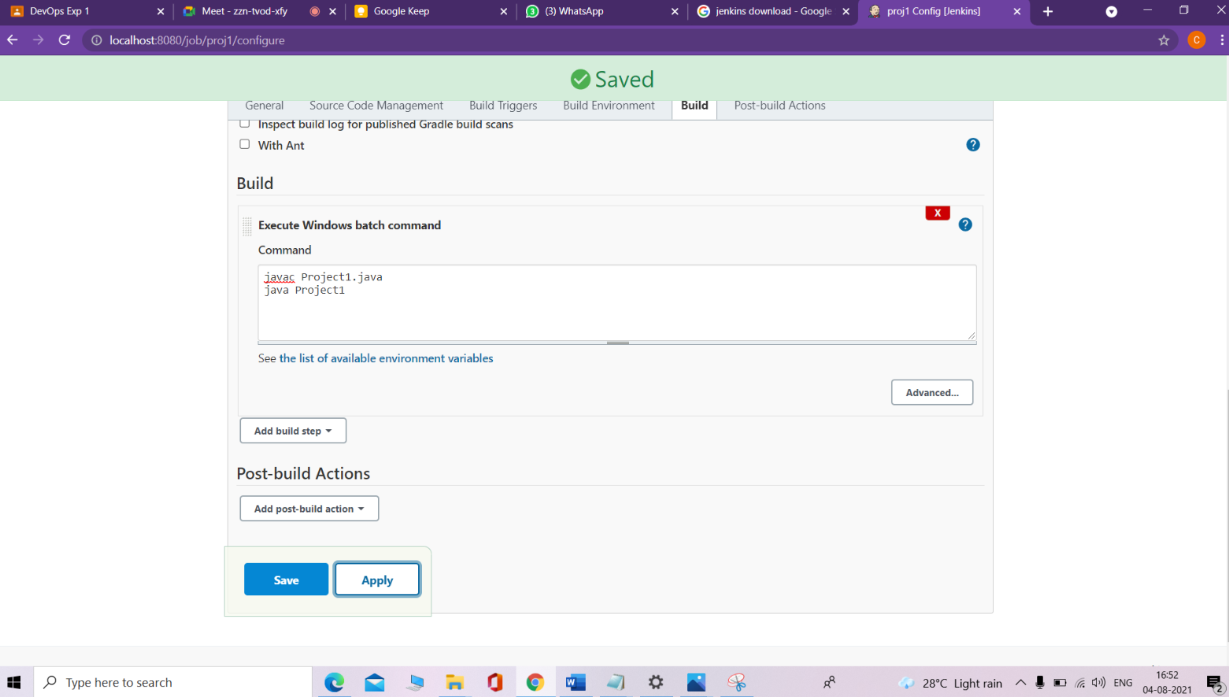

Create a new java file and save it in C:\Windows\System32\config\systemprofile\AppData\Local\Jenkins\.jenkins\workspace\proj1

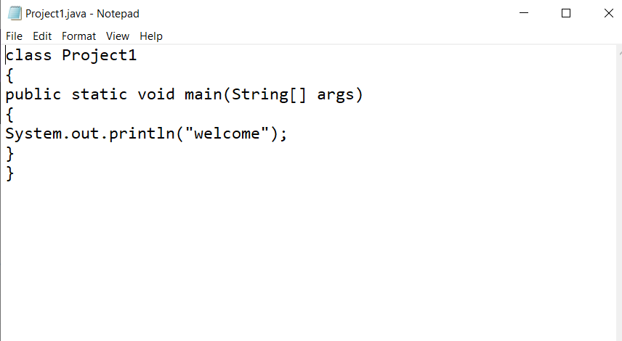

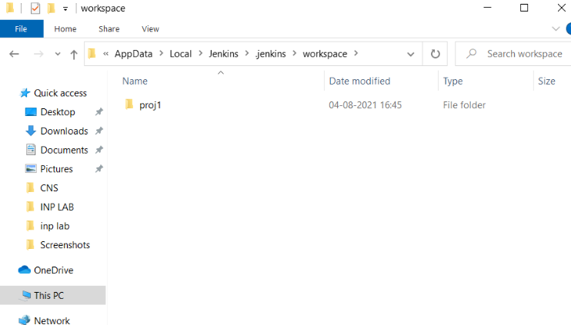

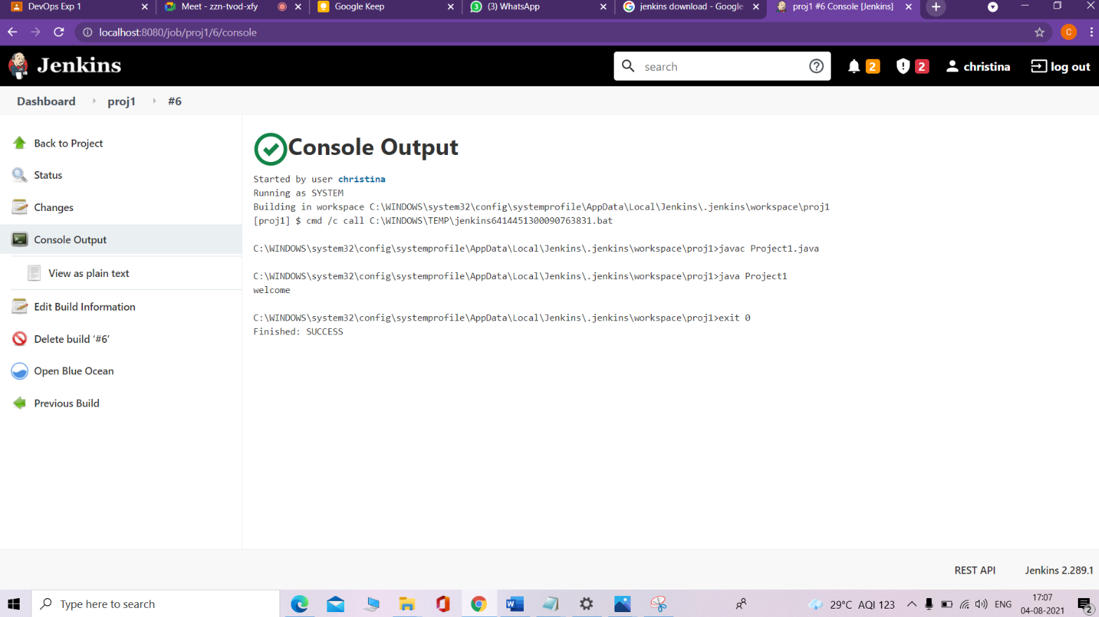

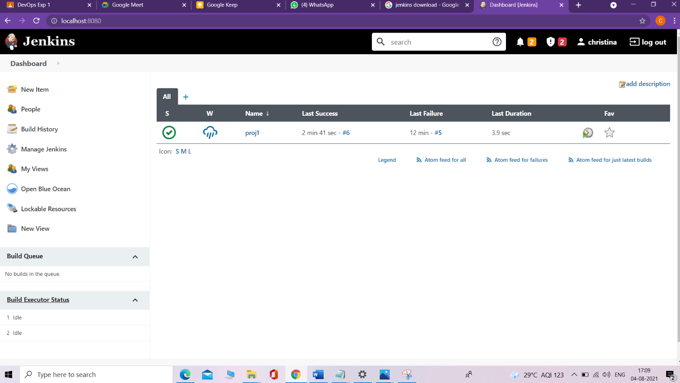

**2. Java freestyle project (parameterized) – 2 String parameters**

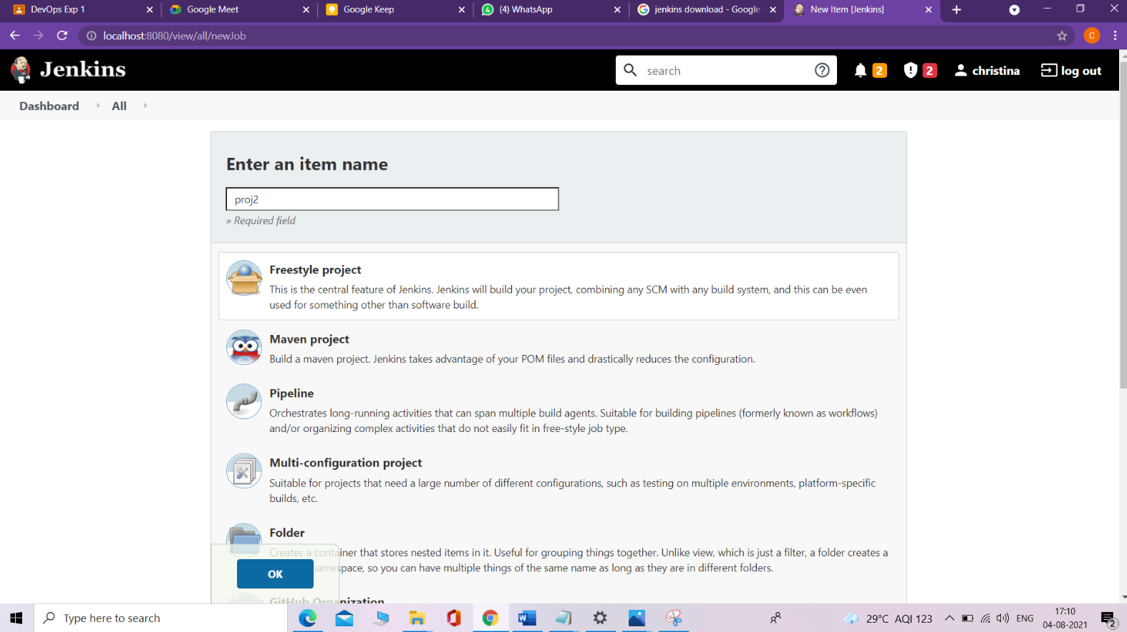

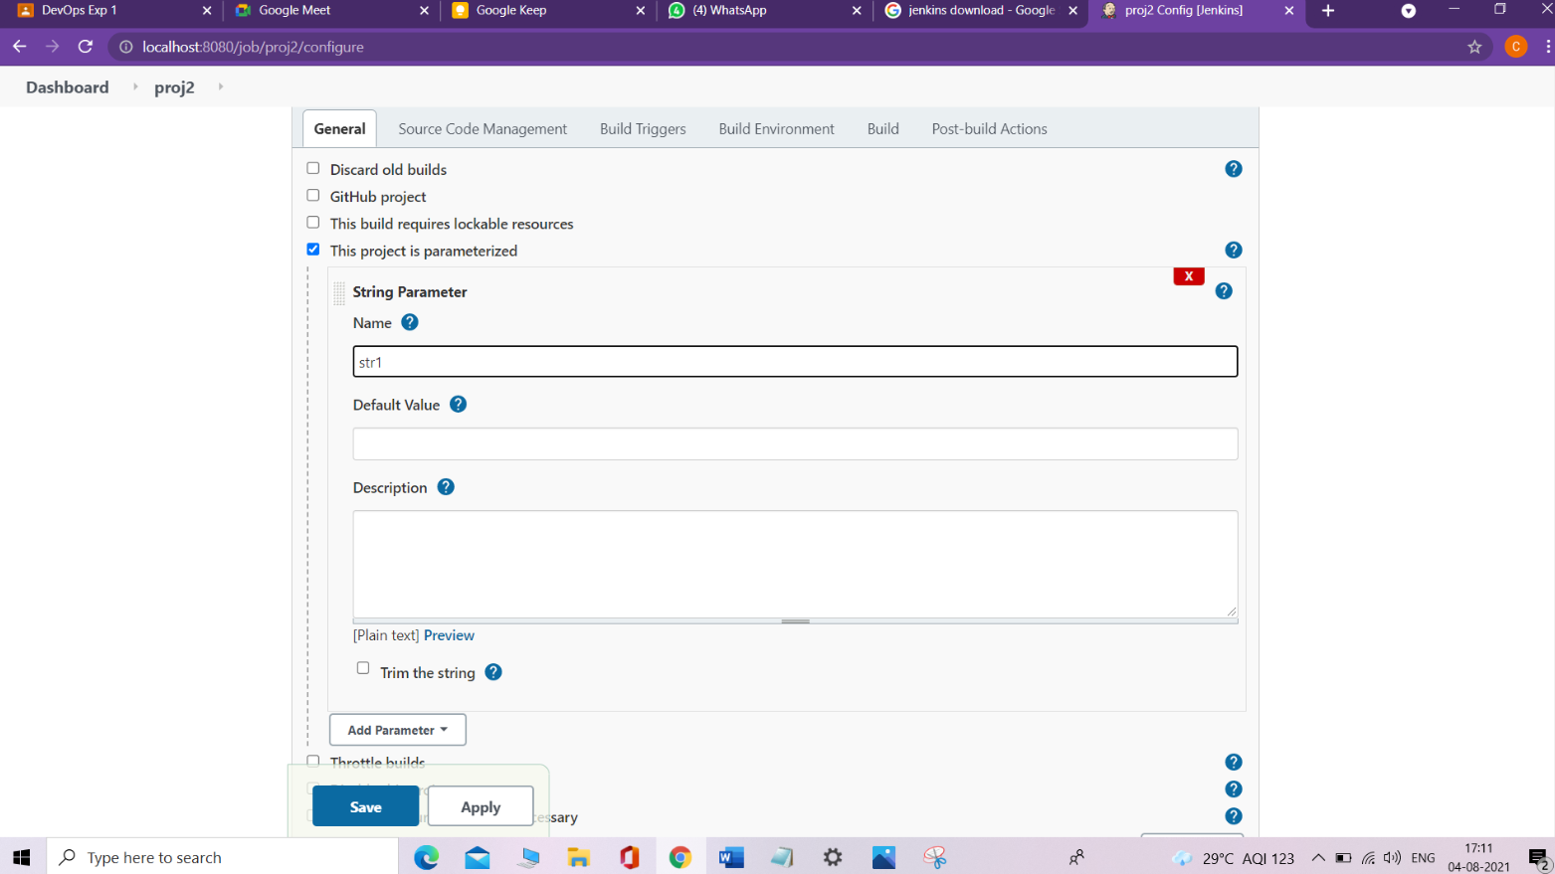

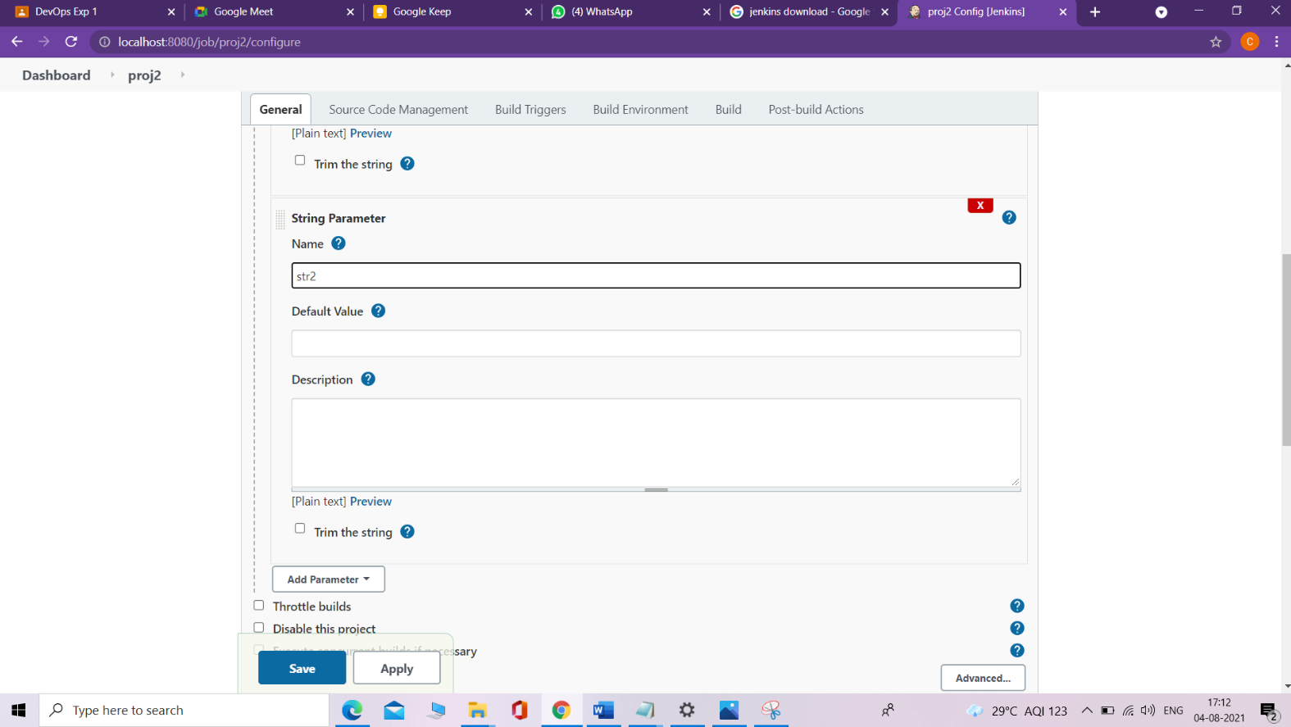

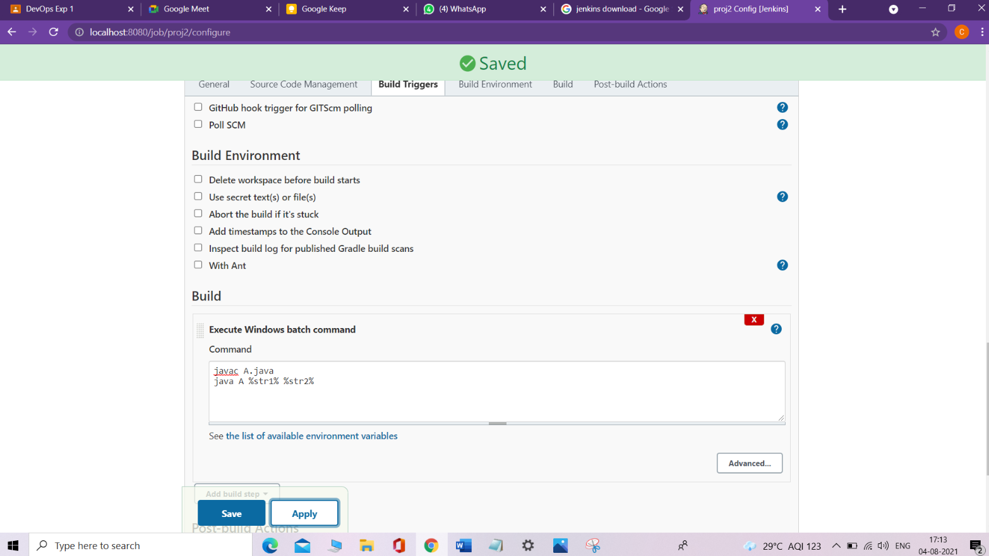

* **Create another java file and save it in C:\Windows\System32\config\systemprofile\AppData\Local\Jenkins\.jenkins\workspace\proj2**

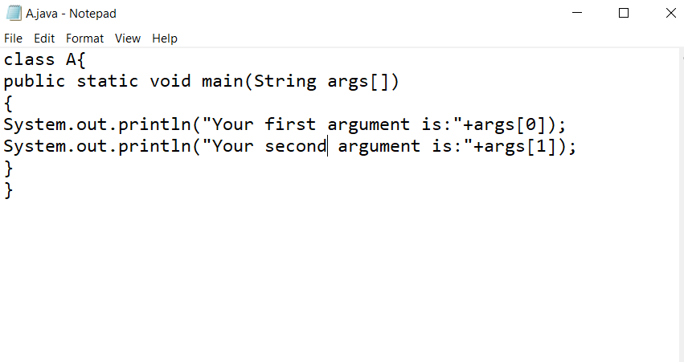

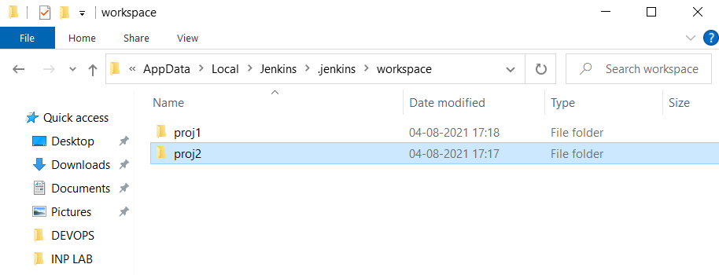

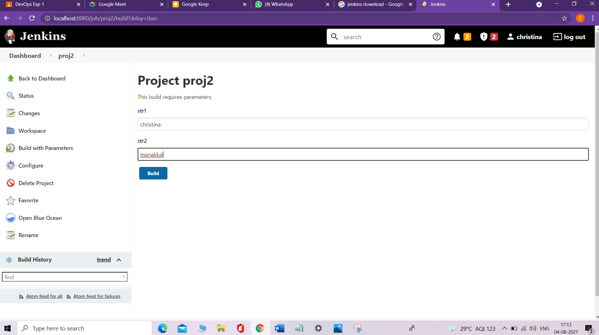

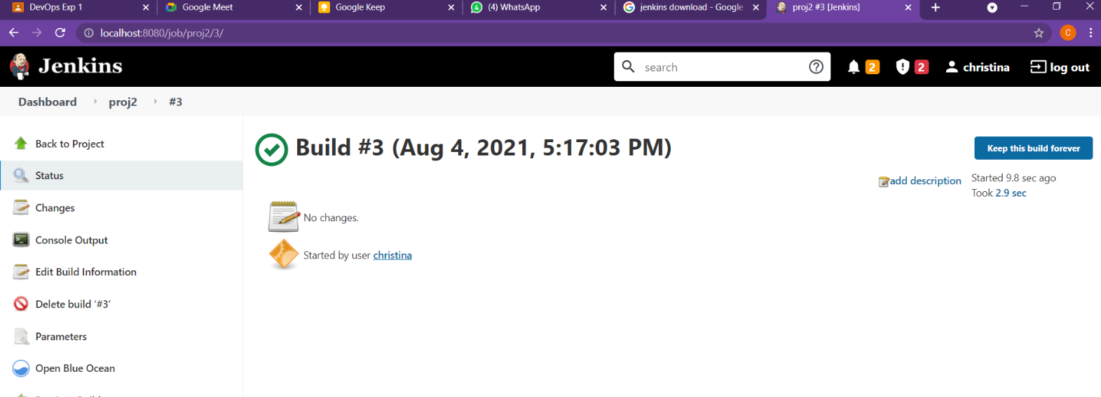

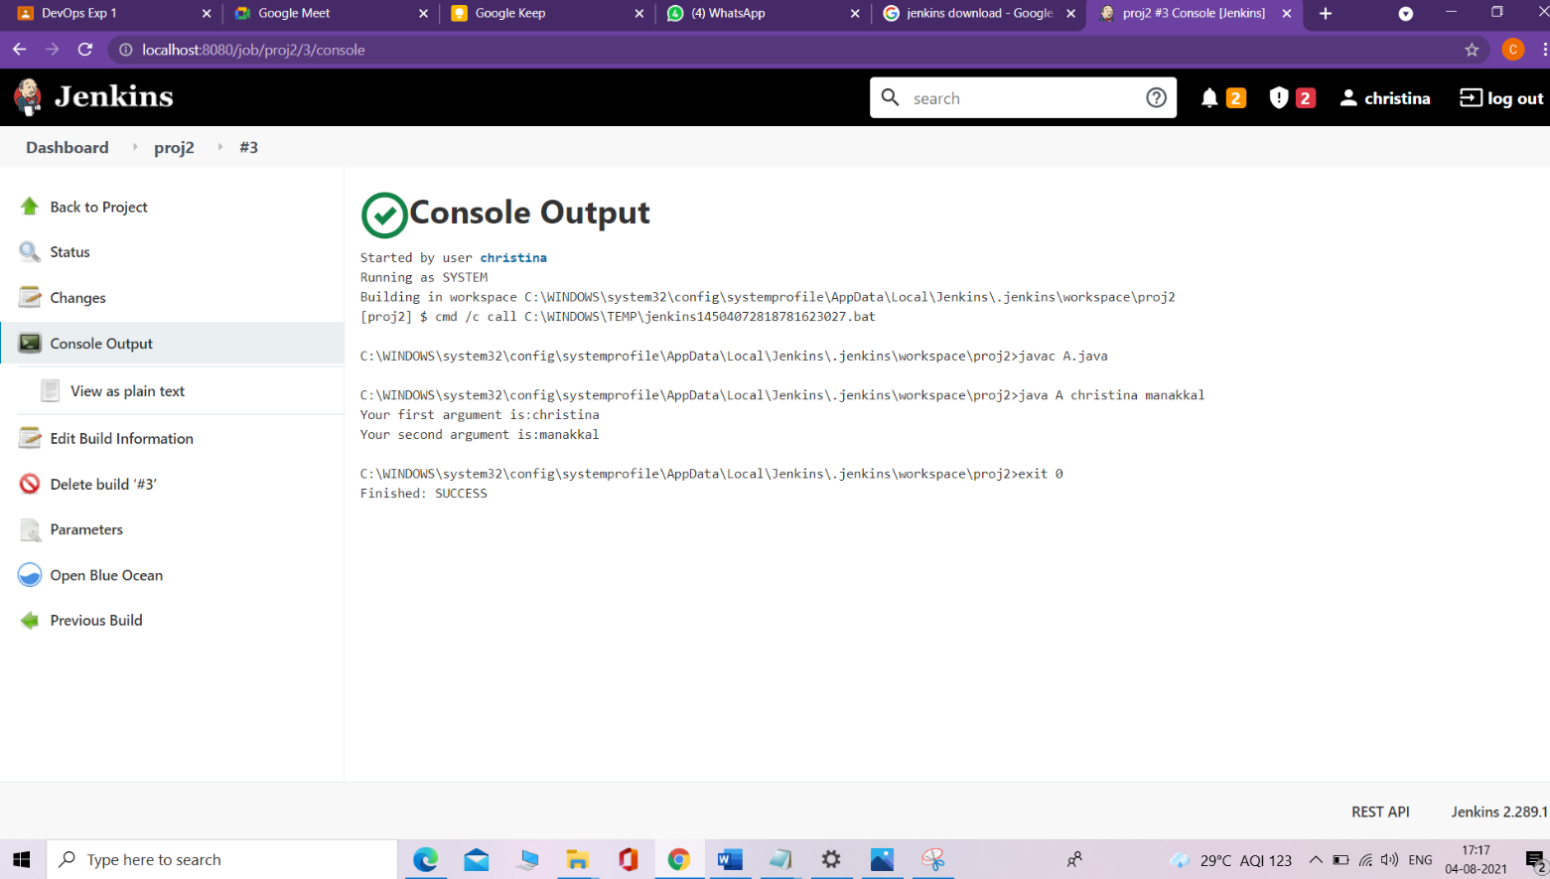

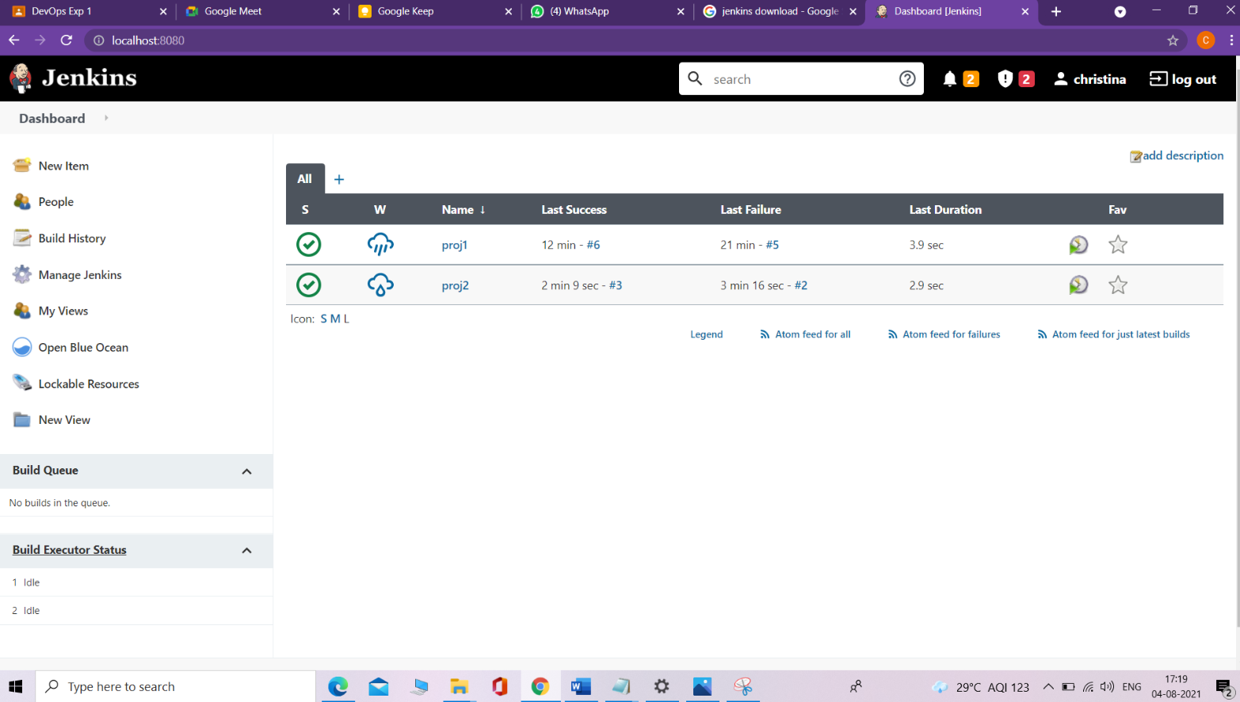

**3. Freestyle project (Simple Windows batch command) – echo**

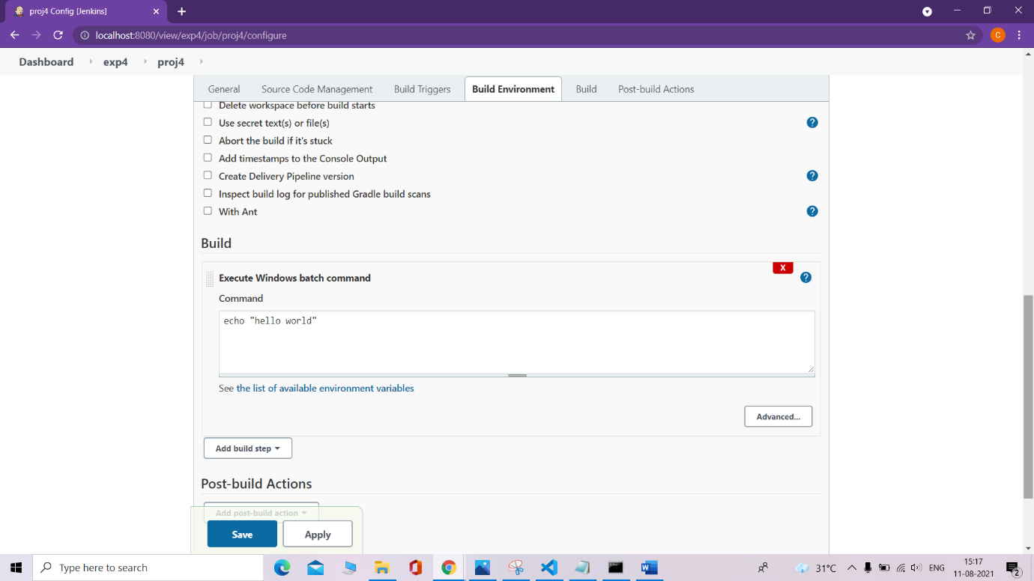

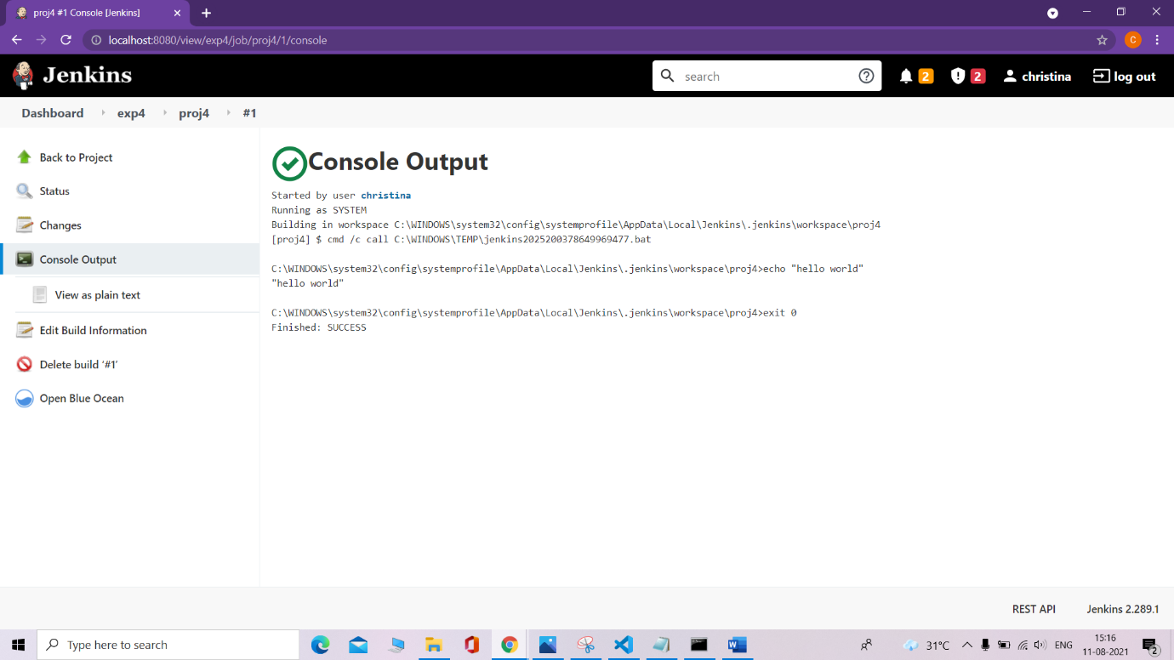

**4. Freestyle parameterized project (Windows batch command) –**

**string, Boolean and choice parameters with echo**

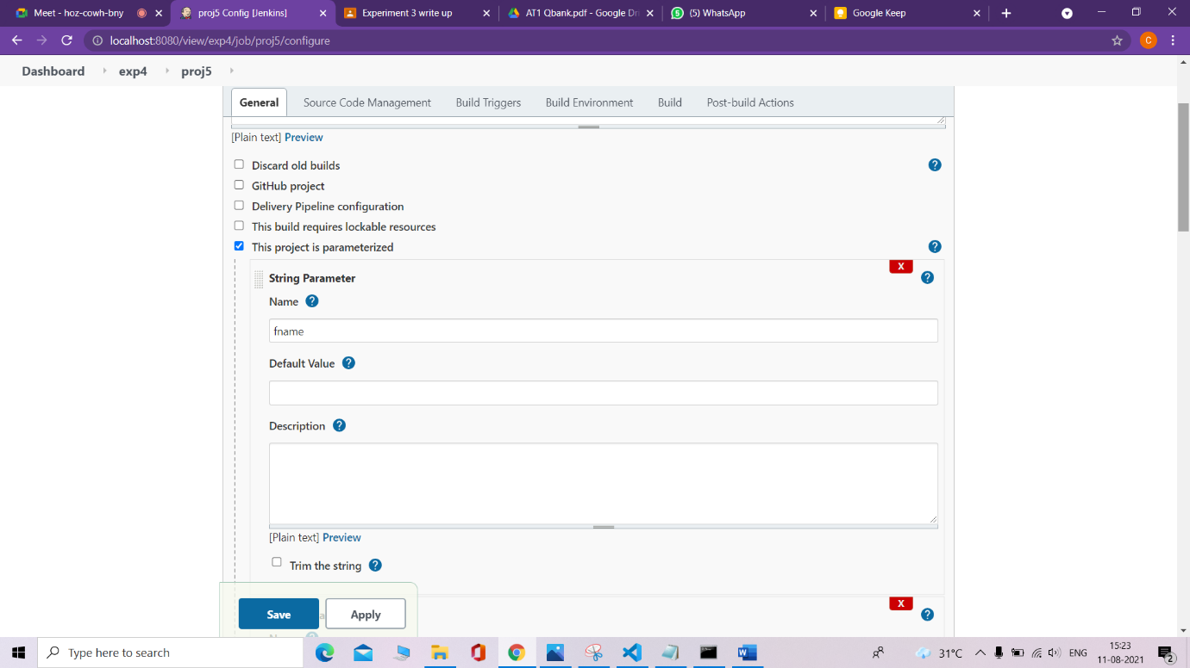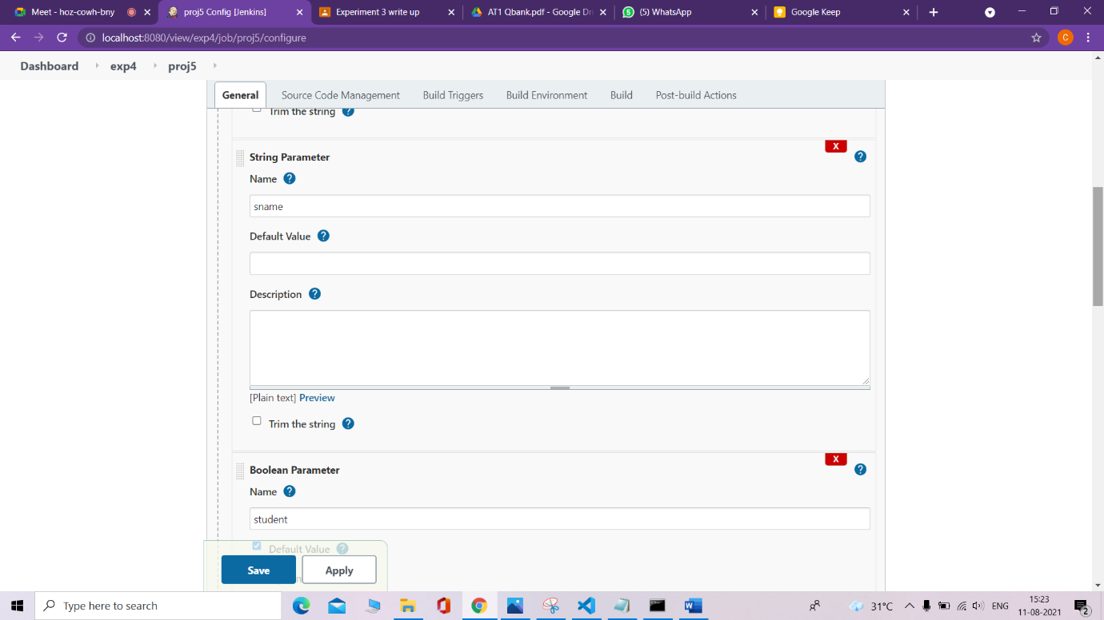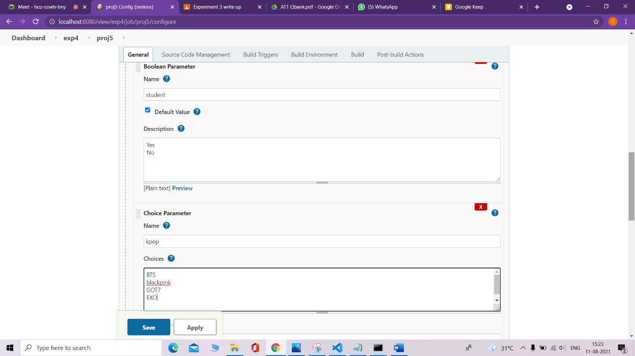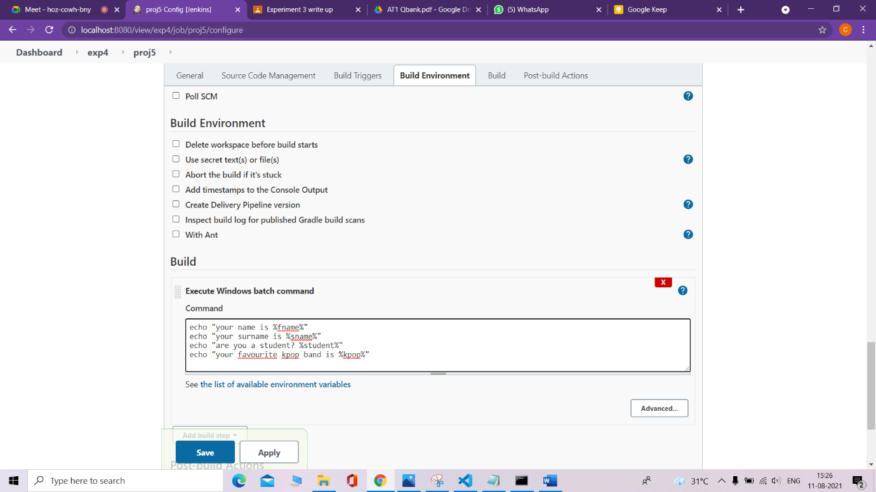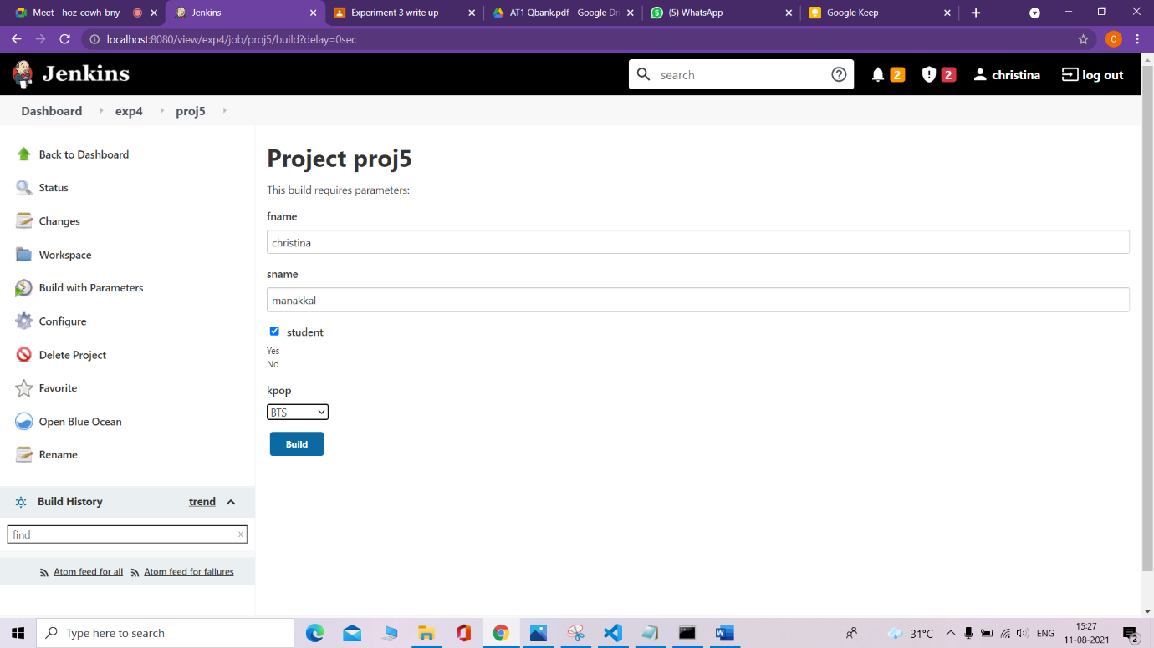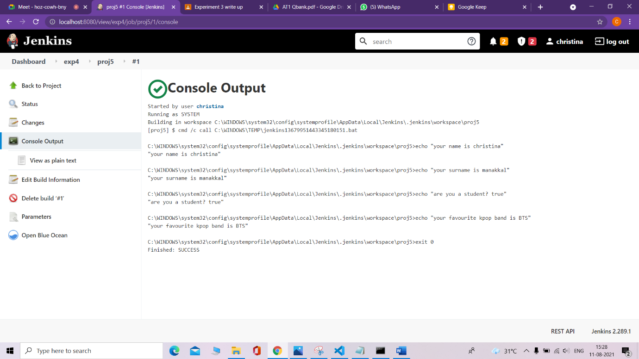

**5. Python freestyle project – simple python script (implicit)**

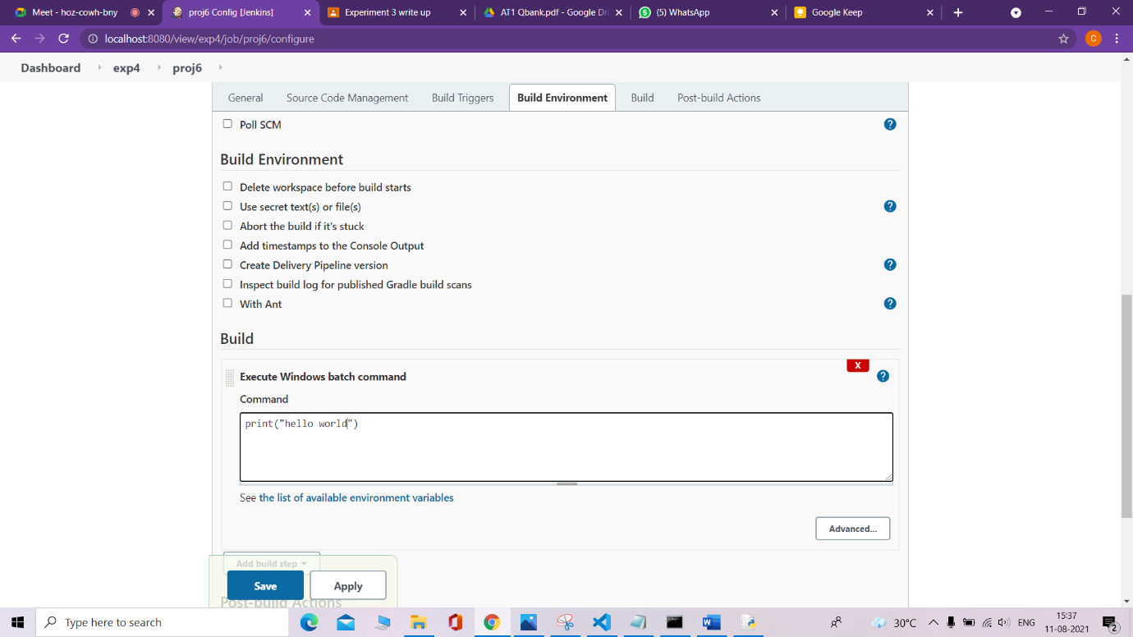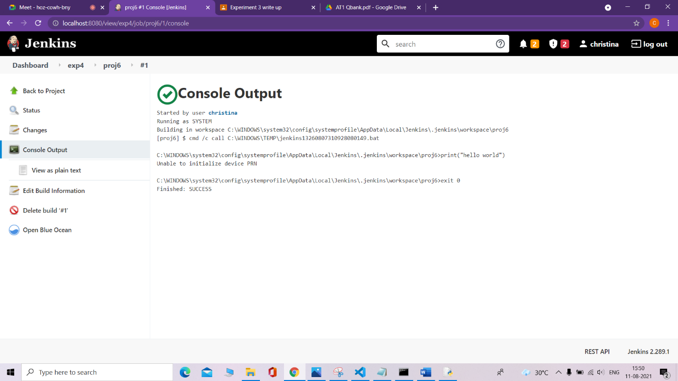

**6. Python freestyle project – simple python file (explicit)**

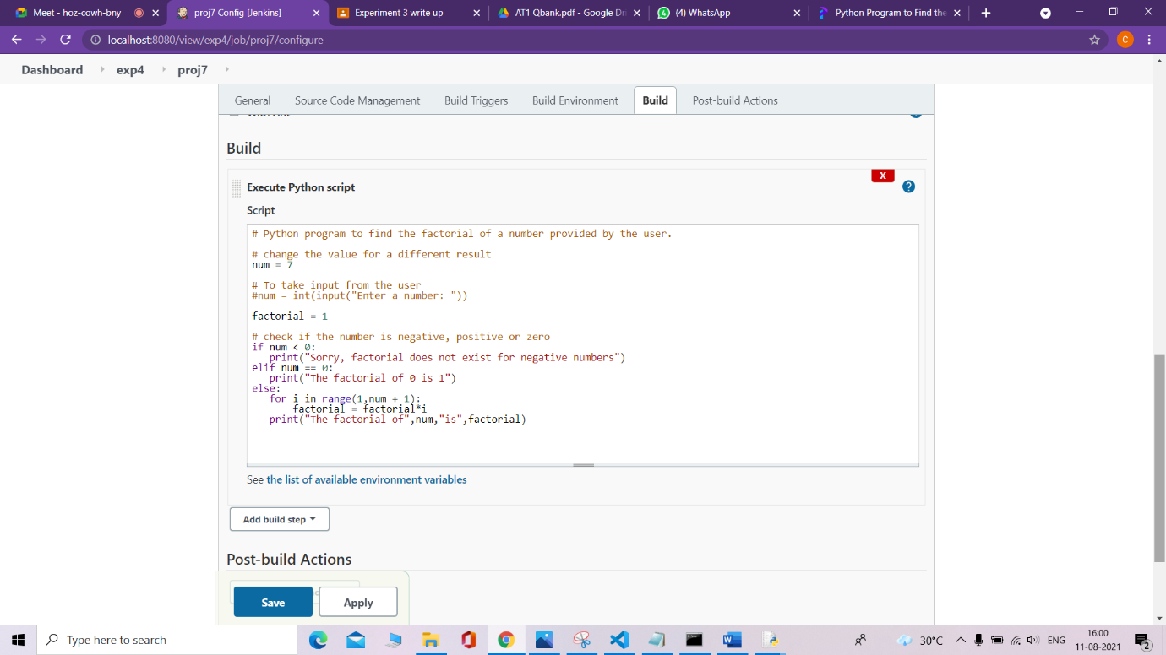

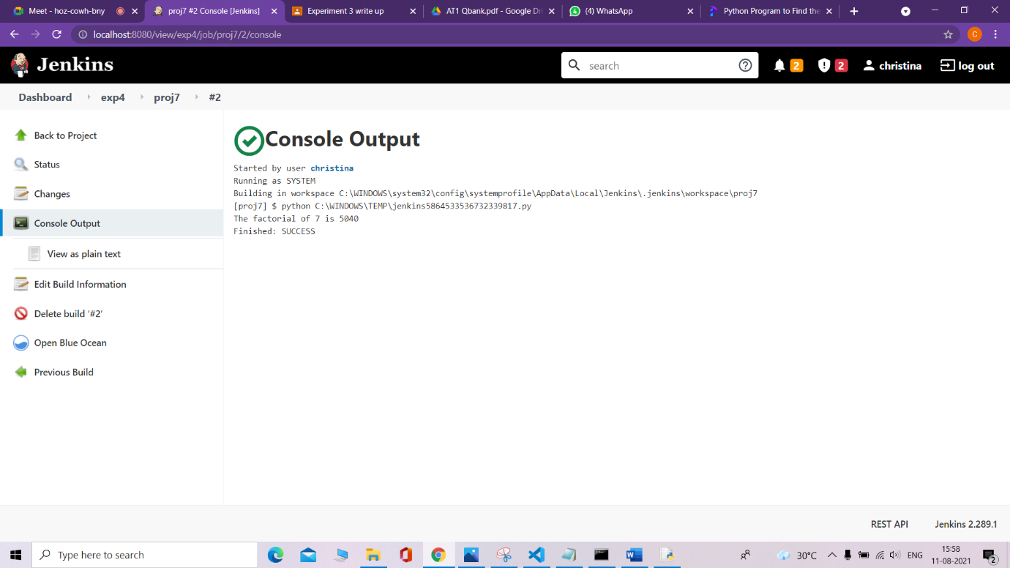

**7. Maven freestyle project – Fork repository and Build goals, verify creation of jar/war**

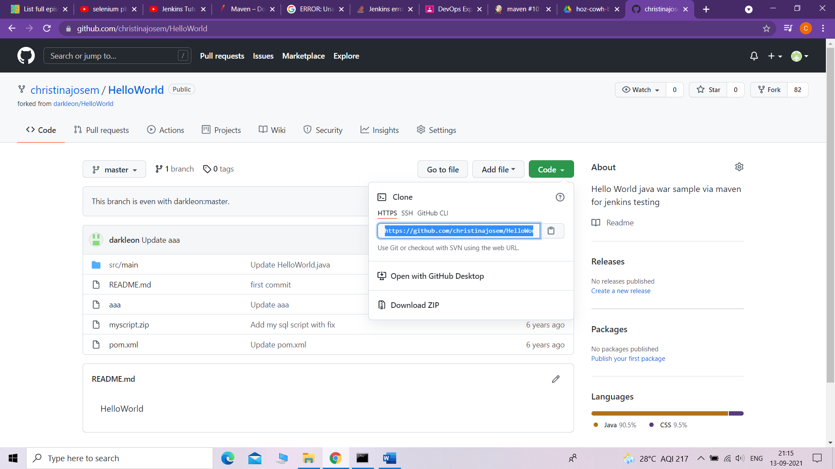

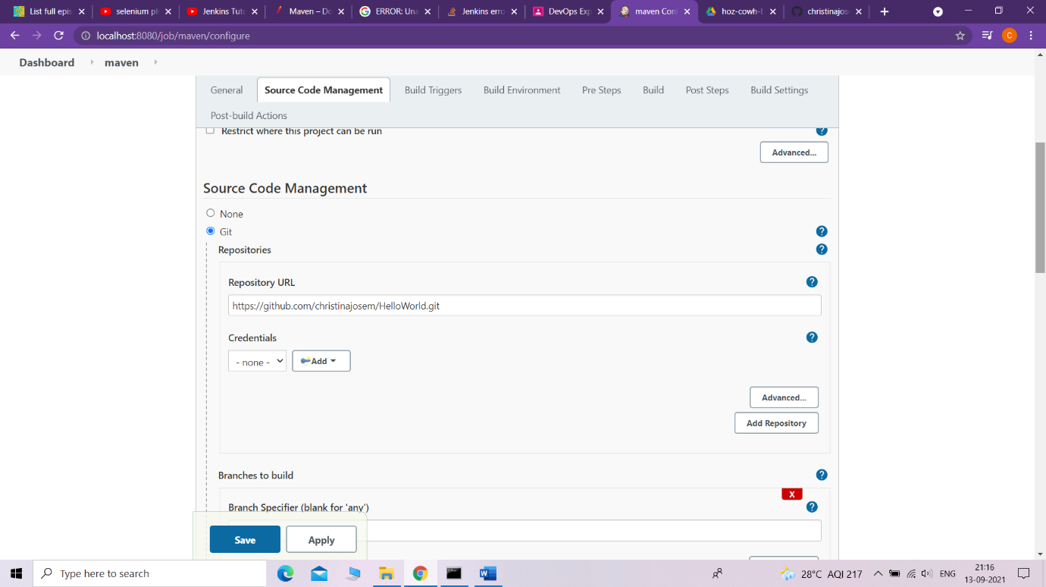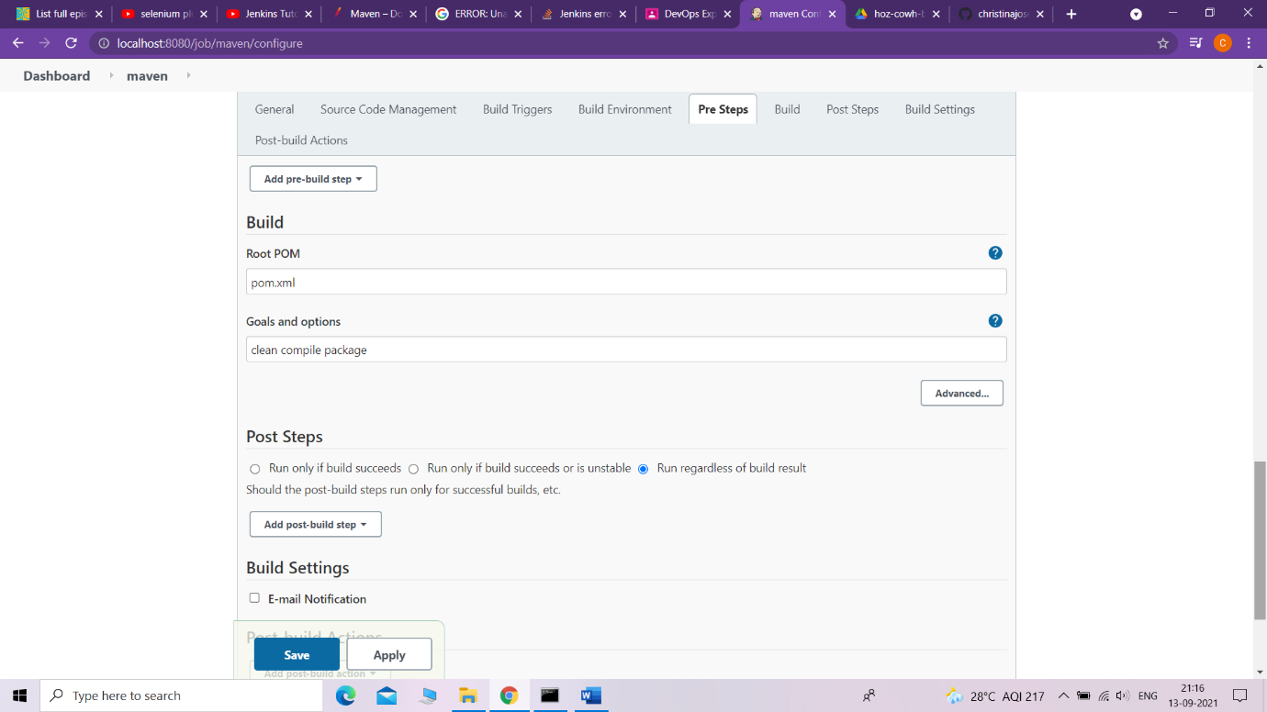

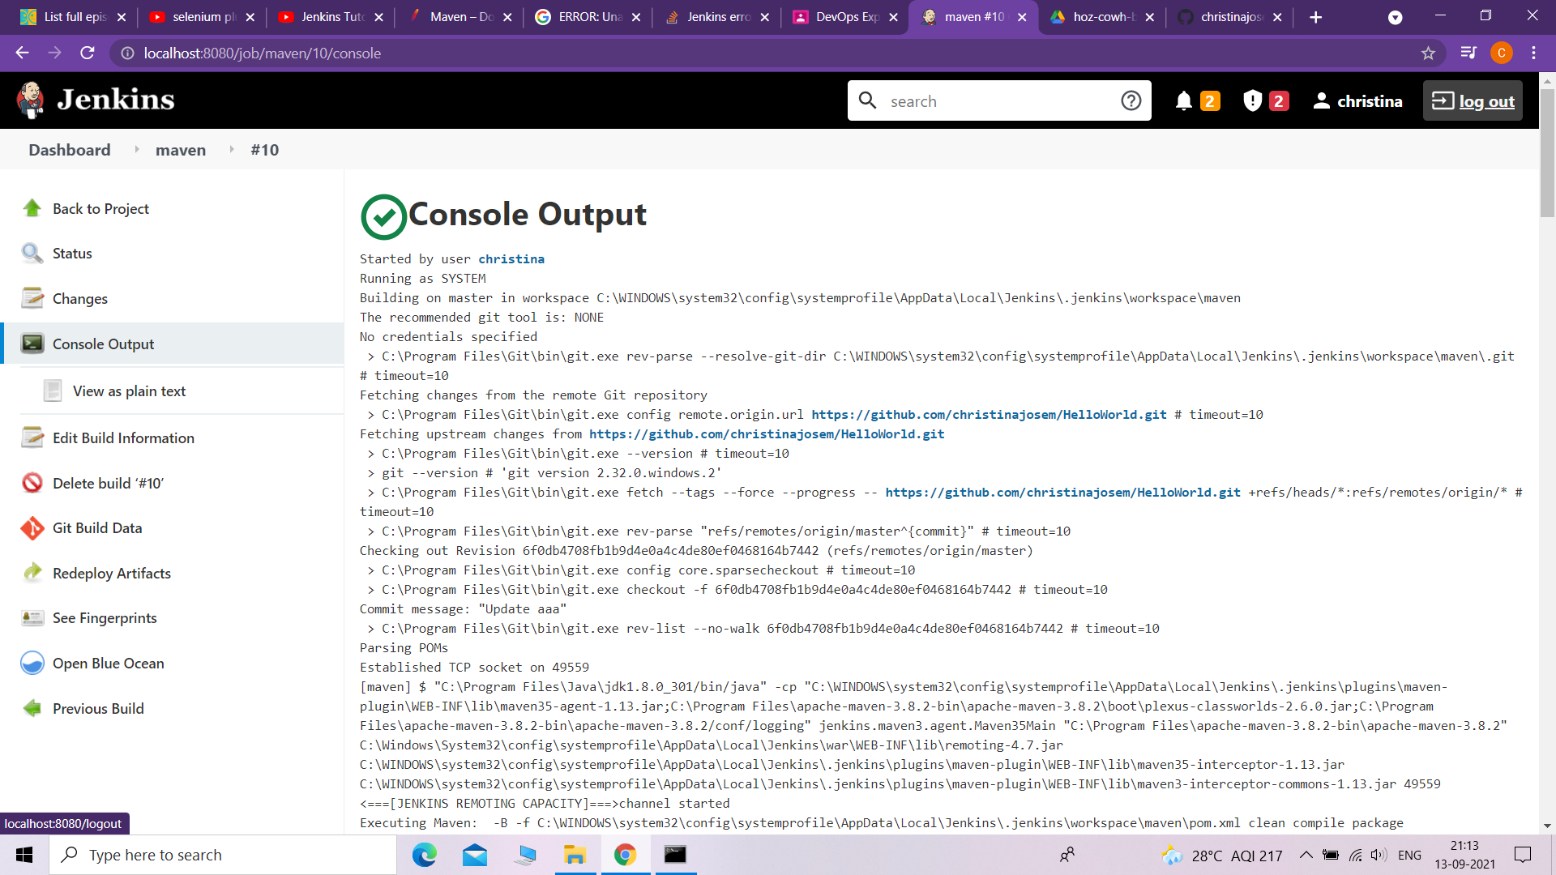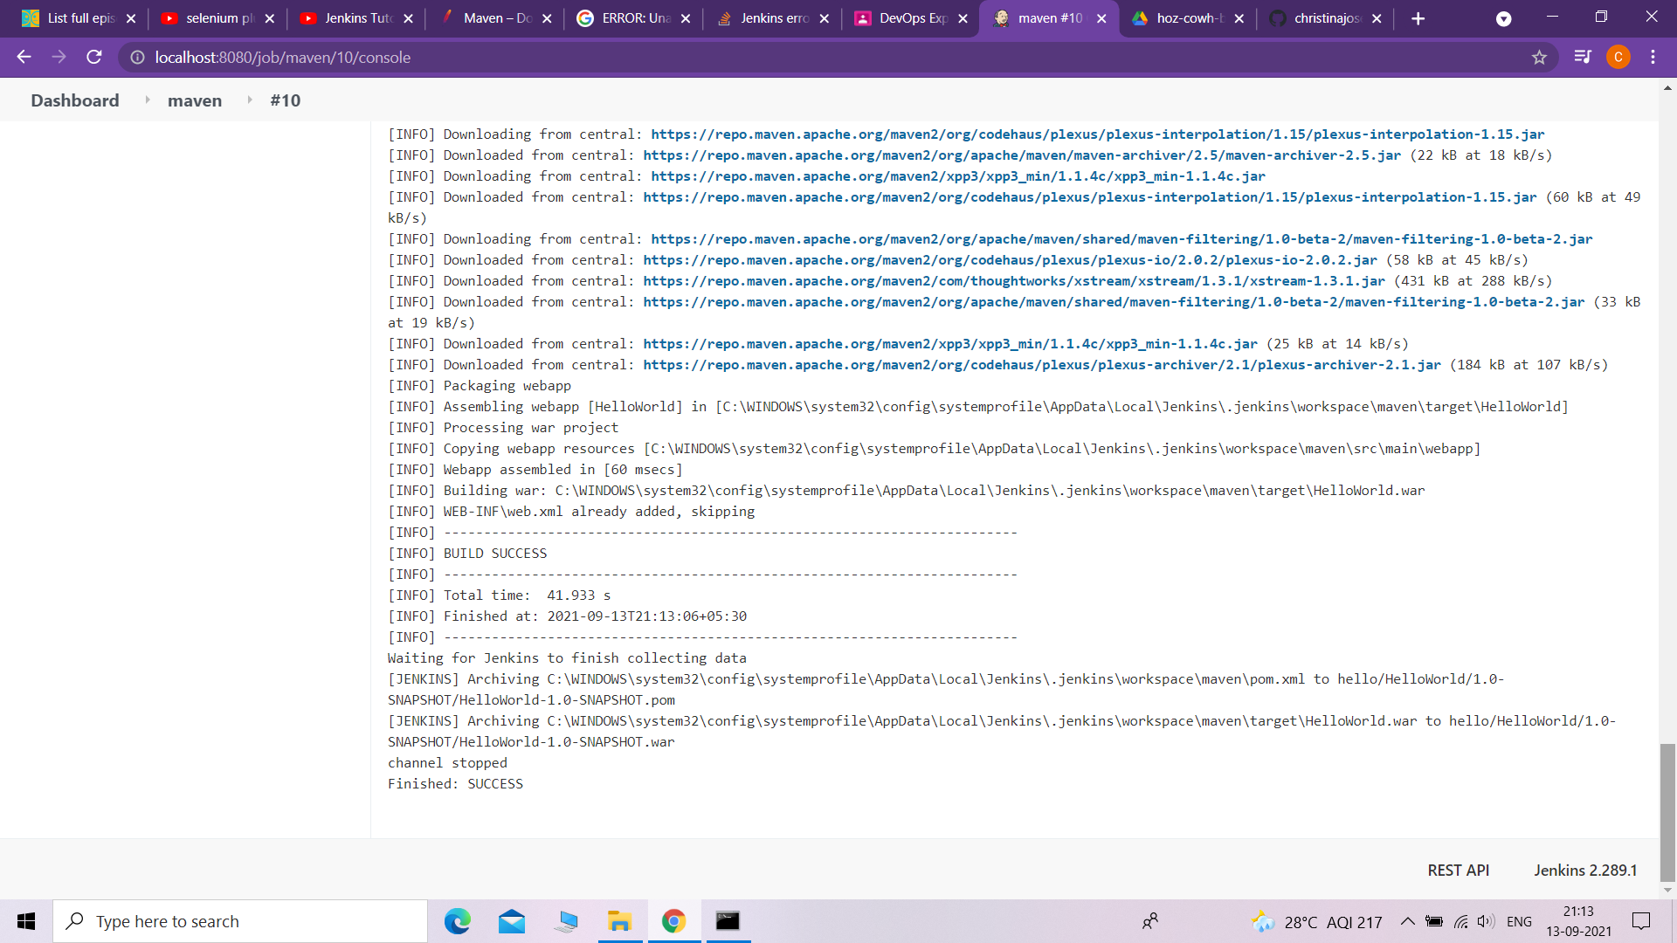

**8. Ant freestyle project - Fork repository and Build goals, verify creation of jar/war**



